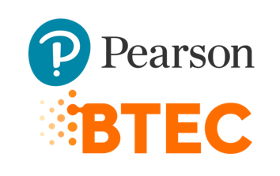



PROGRAM TITLE: Web Design and Development

UNIT TITLE: Web Design & Development

ASSIGNMENT NUMBER: 1

ASSIGNMENT NAME: BKC ANTIQUES

SUBMISSION DATE: 31/3/2022

DATE RECEIVED: 26/7/2022

TUTORIAL LECTURER: Nguyễn Đức Giang

WORD COUNT: 12601

STUDENT NAME: NGUYỄN TUẤN MINH

STUDENT ID: BKC12345

MOBILE NUMBER: 0985296959

|  |
| --- |
| **Summative Feedback:**  **Strength:**  **Weakness:**  **How to improve:**    **Internal verification:** |

Catalog

**FOREWORD 4**

**I. Server technologies and management services associated with hosting and managing websites. 5**

A. DNS **5**

B. Web Server 11

C. Server Hardware 15

D. Web Server Software 16

E. Operating System 19

F. Relationship of 4 elements 21

**II. Website Technologies, tools and software 22**

Front-end and Back-end website technologies 22

Front End Frameworks and Libraries **23**

Relationships between front-end, back-end website technologies , application layers and presentation layer. 32

**III. Analyze the effect of search engines on website performance 35**

1. Definition of Search engine 35

2. Definition of SEO 35

3. Technical solution to improve website index based on SEO 35

**IV. The influence of web devlopment technologies and frameworks on web design and management 35**

1. Some web development technologies and frameworks 36

2. The impact of common web development technologies and framework with regard to website design, functionality and management. 37

➢ Technology 37

➢ Require Function 37

**REFERENCE 41**

Table of Figure

Figure 1 : DNS 7

Figure 2 : DNS’s Function Example 8

Figure 3 : How DNS work 11

Figure 4 : Most popular Web Server today 15

Figure 5 : HTTP 17

Figure 6 : HTTPS 18

Figure 7 : Hardware Server 22

Figure 8 : Web Server Software 22

Figure 9 : Apache 23

Figure 10 : IIS 24

Figure 11 : Tomcat 25

Figure 12 : Operating System 25

Figure 13 : Windows 26

Figure 14 : macOs 27

Figure 15 : Linux 28

Figure 16 : Front-end Languages 31

Figure 17 : Front End Frameworks and Libraries 32

Figure 18 : Relationship between Front-end and back-end 35

Figure 19 : Client-side rendering 35

Figure 20 : Server-side rendering 37

Figure 21 : Header Code 51

Figure 22 : Header 51

Figure 23 : Footer Code 51

Figure 24 : Footer Code 52

Figure 25 : Home Page’s Banner Code 52

Figure 26 : Home Page’s Banner 53

Figure 27 : Home Page’s Product Category Code 54

Figure 28 : Home Page’s Product Category 54

Figure 29 : Home Page’s About Us Code 55

Figure 30 : Home Page’s About Us 55

Figure 31 : Home Page’s Blog Code 55

Figure 32 : Home Page’s Blog 55

Figure 33 : Home Page(1) 56

Figure 34 : Home Page(2) 56

Figure 35 : Product Category code 57

Figure 36 : Product Category 57

Figure 37 : Product Code 58

Figure 38 : Product Page 58

Figure 39 : Product Page 59

Figure 40 : Product detail code 59

Figure 41 : Product Detail 60

Figure 42 : Product Detail Page 60

Figure 43 : Contact information code 61

Figure 44 : Contact information 61

Figure 45 : Contact Message code 62

Figure 46 : Contact Message 62

Figure 47 : Contact Page 63

Figure 48 : About Us Code 64

Figure 49 : About Us Page 64

Figure 50 : Blog code 64

Figure 51 : Blog Page 65

Figure 52 : Detail Blog Code 65

Figure 53 : Detail Blog Page 66

Figure 54 : Search Code 66

Figure 55 : Search Page 67

Figure 56 : Cart Code 67

Figure 57 : Cart Button 67

Figure 58 : Cart Page 68

Table of Table

Table 1 : Compare HTTP and HTTPS 19

Table 2 : Relationship of 4 element regarding design, publish and access 29

Table 3 : Layer 45

Table 4 : Compare Online tool and custom-built 47

Table 5 : Test Case 71

**FOREWORD**

You work for a creative web solutions and marketing company as a designer and content developer. A client ‘BKC Antiques and Auctions’ has asked if you could provide a web-based solution to support the digital marketing and selling of their antique and auction items.

There is some resistance by the owners who do not see the benefit of having a website or online provision as the client is a very traditional ‘brick’ only based company.

Lack of understanding about the costs, mechanics, and benefits of ecommerce, has held them back. However, two of their competitors have started selling antiques online and are getting much wider interest internationally, a market that BKC need to embrace if they are going to grow their customer base over the next two years.

You will be expected to work alongside their newly appointed IT administrator who will be taking over after the project once a solution has been implemented.

As the IT administrator has a limited knowledge regarding websites, your first task is to provide an understanding about server technologies, hosting, performance, user experience and requirements in terms of hardware and software.

1. **Server technologies and management services associated with hosting and managing websites.**
2. **DNS**
3. **Define.**

The Domain Name System (DNS) is the phonebook of the Internet. Humans access information online through [domain names](https://www.cloudflare.com/learning/dns/glossary/what-is-a-domain-name/), like nytimes.com or espn.com. Web browsers interact through [Internet Protocol (IP)](https://www.cloudflare.com/learning/network-layer/internet-protocol/) addresses. DNS translates domain names to [IP addresses](https://www.cloudflare.com/learning/dns/glossary/what-is-my-ip-address/) so browsers can load Internet resources.

Each device connected to the Internet has a unique IP address which other machines use to find the device. DNS servers eliminate the need for humans to memorize IP addresses such as 192.168.1.1 (in IPv4), or more complex newer alphanumeric IP addresses such as 2400:cb00:2048:1::c629:d7a2 (in IPv6).

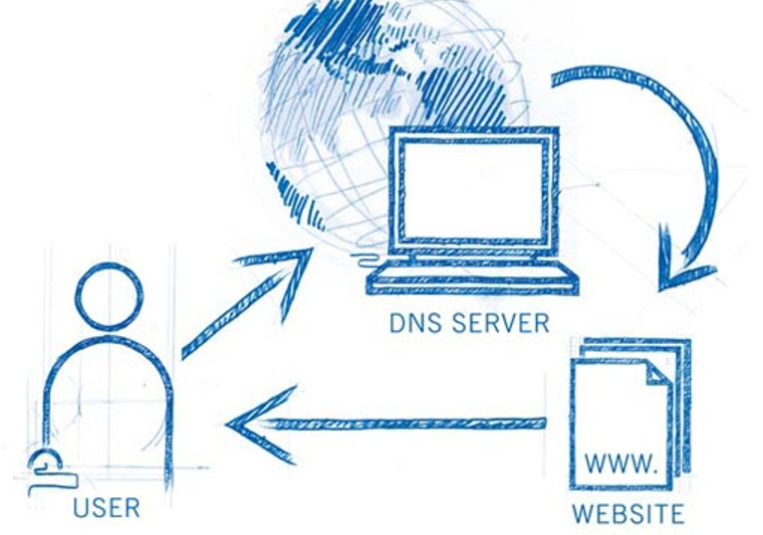

Figure 1: DNS

1. **Function of DNS.**

Each website has a name (a domain name or URL: Uniform Resource Locator) and an IP address. IP addresses consist of 4 groups of numbers separated by periods (IPv4). When you open a Web browser and enter the website name, the browser will go directly to the website without having to go through the IP address of the website. The process of "translating" the domain name into an IP address for the browser to understand and access the website is the job of a DNS server. The DNS helps each other to translate “IP” addresses into “names” and vice versa. Users only need to remember the “name”, no need to remember the IP address (IP addresses are numbers that are difficult to remember).

You should know that DNS can be more than just the “plumbing” of the Internet. Advanced DNS solutions can help do some amazing things, including:

* [Global server load balancing (GSLB)](https://ns1.com/dns-global-server-load-balancing): fast routing of connections between globally distributed data centers
* [Multi CDN](https://ns1.com/multi-cloud): routing users to the CDN that will provide the best experience
* [Geographical routing](https://ns1.com/geographic-routing): identifying the physical location of each user and ensuring they are routed to the nearest possible resource
* [Data center and cloud migration](https://ns1.com/multi-cloud): moving traffic in a controlled manner from on-premise resources to cloud resources
* [Internet traffic management](https://ns1.com/dns-traffic-management): reducing network congestion and ensuring traffic flows to the appropriate resource in an optimal manner

For example, www.tenmien.com into 421,64,874,899 or vice versa translates an IP address into a domain name.

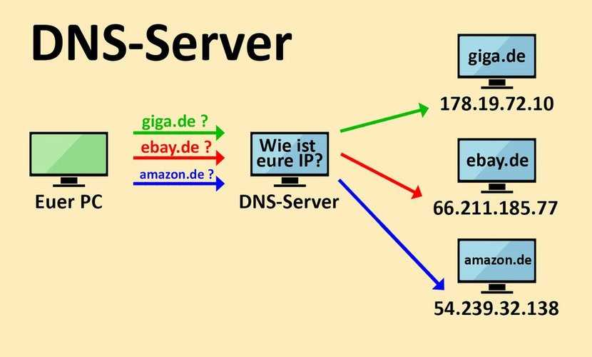

Figure 2: DNS’s Function Example

1. **The principle of operation of DNS**

* Each service provider operates and maintains its own DNS server, including the machines within each of those service providers' own portion of the Internet. That is, if a website looks up the browser's address, the DNS server that parses the site name should be the DNS server of the organization that manages the website, not an organization (the service provider). service) any other.
* INTERNIC (Internet Network Information Center) is responsible for monitoring name domains and their respective DNS servers. INTERNIC is an organization formed by the NSF (National Science Foundation), AT&T and Network Solution, responsible for registering the Internet's domain names. INTERNIC is only responsible for managing all DNS servers on the Internet, not for parsing names for each address.
* DNS has the ability to query other DNS servers for a analyzed name. The DNS servers of each domain name usually have two differences. Theestest, the most of the whole file as a parisation from the machine on the domain about the Internet address, all in the external domain it manager. Second, they respond outside the DNS server trying to parse names inside the domain it manages.
* The DNS server is capable of recording the files that have just parsed the name. To use for the following decal request. The number of name parsers stored in the properties of each DNS.

1. **How DNS works**

DNS servers convert URLs and domain names into IP addresses that computers can understand and use. They translate what a user types into a browser into something the machine can use to find a webpage. This process of translation and lookup is called DNS resolution.

The basic process of a DNS resolution follows these steps:

1. The user enters a web address or domain name into a browser.
2. The browser sends a message, called a [recursive DNS query](https://whatis.techtarget.com/definition/recursive-DNS-query), to the network to find out which IP or network address the domain corresponds to.
3. The query goes to a [recursive DNS server](https://whatis.techtarget.com/definition/recursive-DNS-server), which is also called a recursive resolver, and is usually managed by the internet service provider ([ISP](https://whatis.techtarget.com/definition/ISP-Internet-service-provider)). If the recursive resolver has the address, it will return the address to the user, and the webpage will load.
4. If the recursive DNS server does not have an answer, it will query a series of other servers in the following order: DNS root name servers, top-level domain (TLD) name servers and authoritative name servers.
5. The three server types work together and continue redirecting until they retrieve a DNS record that contains the queried IP address. It sends this information to the recursive DNS server, and the webpage the user is looking for loads. DNS root name servers and TLD servers primarily redirect queries and rarely provide the resolution themselves.
6. The recursive server stores, or [caches](https://www.techtarget.com/searchstorage/definition/cache), the A record for the domain name, which contains the IP address. The next time it receives a request for that domain name, it can respond directly to the user instead of querying other servers.
7. If the query reaches the authoritative server and it cannot find the information, it returns an error message.
8. The entire process querying the various servers takes a fraction of a second and is usually imperceptible to the user.
9. DNS servers answer questions from both inside and outside their own domains. When a server receives a request from outside the domain for information about a name or address inside the domain, it provides the authoritative answer.
10. When a server gets a request from within its domain for a name or address outside that domain, it forwards the request to another server, usually one managed by its ISP.

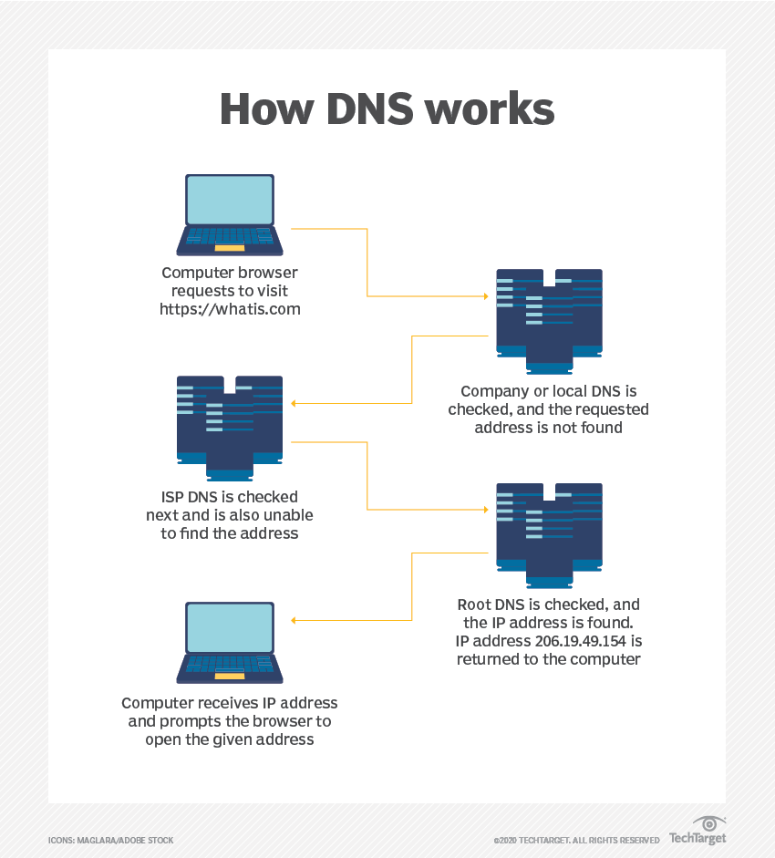

Figure 3: How DNS work

1. **Type of DNS**
2. **DNS Query**

There are three types of queries in the DNS system:

* **Recursive Query**

In a recursive query, a DNS client provides a hostname, and the DNS Resolver “must” provide an answer—it responds with either a relevant resource record, or an error message if it can't be found. The resolver starts a recursive query process, starting from the DNS Root Server, until it finds the Authoritative Name Server (for more on Authoritative Name Servers see DNS Server Types below) that holds the IP address and other information for the requested hostname.

* **Iterative Query**

In an iterative query, a DNS client provides a hostname, and the DNS Resolver returns the best answer it can. If the DNS resolver has the relevant DNS records in its cache, it returns them. If not, it refers the DNS client to the Root Server, or another Authoritative Name Server which is nearest to the required DNS zone. The DNS client must then repeat the query directly against the DNS server it was referred to.

* **Non-Recursive Query**

A non-recursive query is a query in which the DNS Resolver already knows the answer. It either immediately returns a DNS record because it already stores it in local cache, or queries a DNS Name Server which is authoritative for the record, meaning it definitely holds the correct IP for that hostname. In both cases, there is no need for additional rounds of queries (like in recursive or iterative queries). Rather, a response is immediately returned to the client.

1. **DNS Server**

The following are the most common DNS server types that are used to resolve hostnames into IP addresses.

* **DNS Resolver**

A DNS resolver (recursive resolver), is designed to receive DNS queries, which include a human-readable hostname such as “www.example.com”, and is responsible for tracking the IP address for that hostname.

* **DNS Root Server**

The root server is the first step in the journey from hostname to IP address. The DNS Root Server extracts the Top Level Domain (TLD) from the user’s query — for example, www.example.com —... provides details for the .com TLD Name Server. In turn, that server will provide details for domains with the .com DNS zone, including “example.com”.

There are [13 root servers worldwide](https://en.wikipedia.org/wiki/Root_name_server), indicated by the letters A through M, operated by organizations like the Internet Systems Consortium, Verisign, ICANN, the University of Maryland, and the U.S. Army Research Lab.

* **Authoritative DNS Server**

Higher level servers in the DNS hierarchy define which DNS server is the “authoritative” name server for a specific hostname, meaning that it holds the up-to-date information for that hostname.

The Authoritative Name Server is the last stop in the name server query—it takes the hostname and returns the correct IP address to the DNS Resolver (or if it cannot find the domain, returns the message NXDOMAIN).

1. **DNS Record**

DNS servers create a DNS record to provide important information about a domain or hostname, particularly its current IP address. The most common DNS record types are:

* Address Mapping record (A Record)—also known as a DNS host record, stores a hostname and its corresponding IPv4 address.
* IP Version 6 Address record (AAAA Record)—stores a hostname and its corresponding IPv6 address.
* Canonical Name record (CNAME Record)—can be used to alias a hostname to another hostname. When a DNS client requests a record that contains a CNAME, which points to another hostname, the DNS resolution process is repeated with the new hostname.
* Mail exchanger record (MX Record)—specifies an SMTP email server for the domain, used to route outgoing emails to an email server.
* Name Server records (NS Record)—specifies that a DNS Zone, such as “example.com” is delegated to a specific Authoritative Name Server, and provides the address of the name server.
* Reverse-lookup Pointer records (PTR Record)—allows a DNS resolver to provide an IP address and receive a hostname (reverse DNS lookup).
* Certificate record (CERT Record)—stores encryption certificates—PKIX, SPKI, PGP, and so on.
* Service Location (SRV Record)—a service location record, like MX but for other communication protocols.
* Text Record (TXT Record)—typically carries machine-readable data such as opportunistic encryption, sender policy framework, DKIM, DMARC, etc.
* Start of Authority (SOA Record)—this record appears at the beginning of a DNS zone file, and indicates the Authoritative Name Server for the current DNS zone, contact details for the domain administrator, domain serial number, and information on how frequently DNS information for this zone should be refreshed.

1. **How domain names are organized and managed**

Domain Names are host names that the [Domain Name System (DNS)](https://www.domaintools.com/support/key-terms-definitions/" \l "dns) uses to identify and map to websites and other [Internet Protocol (IP)](https://www.domaintools.com/support/key-terms-definitions/" \l "ip) resources. A good parallel would be to think of domain names as street names. Street names are important because they help people navigate. The IP addresses, on the other hand, are the geographical location of the streets themselves

1. **Organized**

Domain names are organized via [subdomains](https://www.domaintools.com/support/key-terms-definitions/" \l "subdomain) which are subordinate levels of the Domain Name System [root domain](https://www.domaintools.com/support/key-terms-definitions/" \l "root). [Top-level domains (TLDs)](https://www.domaintools.com/support/key-terms-definitions/" \l "tld) are the first-level set of domain names, and include [generic top-level domains (gTLDs)](https://www.domaintools.com/support/key-terms-definitions/" \l "gtld) such as .com, .net and .org as well as [country code top-level domains (ccTLDs)](https://www.domaintools.com/support/key-terms-definitions/" \l "cctld). The ccTLDs are noted to the right of the dot, such as .fr or .au in the examples google.fr and google.com.au. Under Top-level domains, there are second and third-level domain names in the DNS hierarchy, such as DomainTools or Google. These domains are typically available for end-users to reserve so they can run web sites, create publicly accessible Internet resources, and connect the Internet to local area networks. Second level domains typically provide the name of the organization and/or are descriptive of the service provided, while third level domains is typically used to refer to a specific server within an organization.

1. **Managed**

This is a job related to the synthesis of management methods that users need to implement to maintain the right to use their domain name as well as avoid unnecessary problems arising.

If a problem occurs because the domain name management process is not close and appropriate, the owner of that domain name must take full responsibility.

1. **Several ways to manage domains**

**Way 1: Change the domain name administration information**

If your agency or organization changes its name. Users change contact information including information about name, address, phone, email address, etc. Although they do not know specifically what the organization that manages the domain name is, if there is a change in information, information, you need to notify the supplier to update the correct information.

**Way 2: Pay domain registration and maintenance fees**

After registering a new domain name, you need to pay the full fee. After using the domain name, the owner is responsible for paying the fee when wanting to renew the domain name. Paying a maintenance fee is extremely necessary if you want to manage a good domain name.

**Way 3: Pay the domain name renewal fee 10-15 days in advance**

The domain name owner must check the validity status of the registered domain name to complete the domain name renewal procedure. At the same time, if possible, please extend it 10-15 days earlier than the deadline. This is a very simple option for you wondering what is a simple way to manage domain names.

1. **Web Server**
2. **Define**

A web server is a server that installs web application servers. Web server is capable of receiving requests from web browsers and sending responses to clients via HTTP or other protocols. There are many different web servers such as: Apache, Nginx, IIS, etc. The most popular web server today:

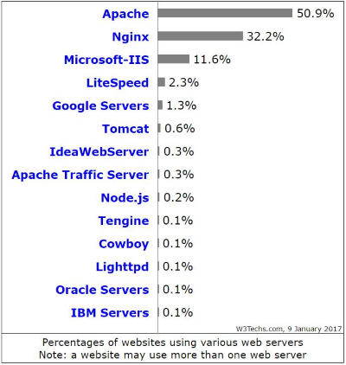

Figure 4: Most popular Web Server today

1. **How Web Server works**

Whenever you view a web page on the internet, you are requesting that page from a web server. When you enter the URL on your browser (eg https://abc.vn) it will take the following steps to send you a response back.

**Browsers resolve domain names to IP addresses**

Your web browser first needs to determine which IP address the domain name abc.vn points to. The browser will request information from one or more DNS servers (through the internet). The DNS server will tell the browser which IP address the domain name should point to which is also where the website is located.

Now that the web browser knows the IP address of the website, it can request the full URL from the webserver.

**Web Server resends client Requested page**

The web server responds by sending back the requested information… If the page doesn't exist or another error occurs, it will resend the appropriate error message.

**The browser displays the web page**

Your web browser receives the html css files (many more)… and renders the page as requested.

1. **Protocol**
2. **HTTP Protocol**

* **Define**

HTTP (Hypertext Transfer Protocol) is a protocol for transferring hypertext. This is the standard protocol for the World Wide Web (www) to transmit data in the form of text, audio, images, videos from the Web Server to the user's web browser and vice versa.

HTTP is an application protocol of the TCP/IP protocol suite (the foundational protocols for the Internet). The TCP/IP protocol suite is a set of communication protocols that implement the protocol stack on which the Internet and most commercial computer networks run. This protocol suite is named after two main protocols, TCP (Transmission Control Protocol) and IP (Internet Protocol)

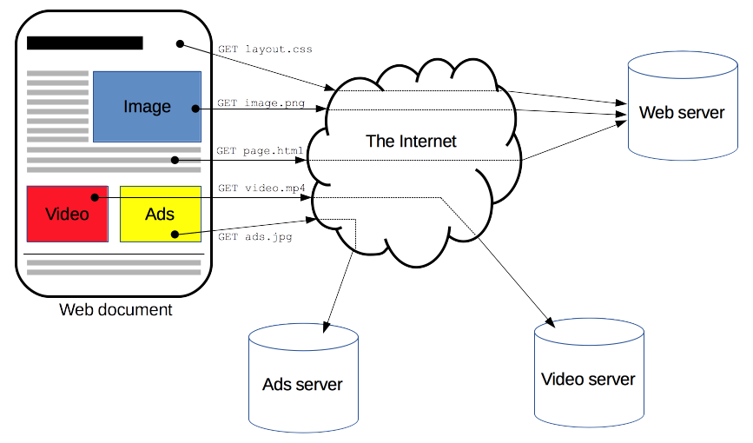

Figure 5: HTTP

* **How HTTP Works**

HTTP works under the Client (client) – Server (server) model. Website access is conducted based on the communication between the two objects above. When you access a website over the HTTP protocol, the browser makes connections to the website's server through the IP address provided by the DNS domain name resolution system. The server, after receiving the command, will return the corresponding command to help display the website, including content such as: text, photos, video, audio, ...

In the process of connecting and exchanging information, your browser will automatically assume that the IP address comes from the server of the website you want to access without any authentication measures. The information sent over the HTTP protocol (including IP address, information you enter into the website ...) is also not encrypted and secure. This is a loophole that many hackers have taken advantage of to steal user information, commonly known as sniffing attacks.

1. **HTTPS Protocol**

* **Define**

HTTPS (Hypertext Transfer Protocol Secure) is a secure hypertext transfer protocol. In essence, this is the HTTP protocol but integrates an SSL Security Certificate to encrypt communication messages to increase security. Understandably, HTTPS is a more secure, secure version of HTTP.

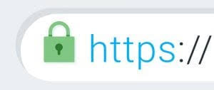

Figure 6: HTTPS

* **How HTTPS Works**

HTTPS works similar to HTTP, but with the addition of SSL (Secure Sockets Layer) or TLS (Transport Layer Security) certificates. Currently, these are the leading security standards for millions of websites worldwide.

Both SSL and TLS use an asymmetric PKI (Public Key Infrastructure) system. This system uses two “keys” to encrypt communications, a “public key” and a “private key”. Anything encrypted with the public key can only be decrypted with the private key, and vice versa. These standards ensure that content is encrypted before transmission, and decrypted upon receipt. This makes the hacker even if he interrupts to get the information, he can't "understand" that information.

1. **Compare**

|  |  |  |
| --- | --- | --- |
| **Information** | **HTTP** | **HTTPS** |
| **Port** | 80 | 443 |
| **Encode** | Does not use | Use |
| **Method** | The browser opens a TCP connection then sends an http request to the server, the server responds via http to the browser and then the TCP connection is closed | First authentication is done then select the ciphers or cryptographic algorithms that the client and server support then encryption technique is used and then a encrypted SSL(Secure Socket Layer) connection is created. and then the http request will work to continue… |
| **Application** | Used with website that do not require security as Blog | Used with website that needed to be secure and reliable during conversion process as Banking, Social Website |
| **Url** | http:// | https:// |
| **Work** | Works at the “Application Layer” in the OSI model | Works at the “Transport Layer” in OSI model |
| **Security** | Because the data is not authenticated securely, it can’t be guarantee that your infomation is being leaking, or that you are providing information for a real website or a fake website. | When a client accesses a website, the HTTPS protocol will assist in verifying the identity of that website through a security certificate check (Security Certificate). |

Table 1: Compare HTTP and HTTPS

=> Should use Https in website because:

* HTTPS secures user information
* Avoid scams with fake websites
* HTTPS protocol increases website credibility for users

1. **Some Communication Protocols**

**FTP•**

* File Transfer Protocol (FTP) is a standard Internet protocol for transmitting files between computers on the Internet over TCP/IP connections.•
* FTP is a client-server protocol that relies on two communications channels between client and server: a command channel for controlling the conversation and a data channel for transmitting file content.•
* Clients initiate conversations with servers by requesting to download a file. Using FTP, a client can upload, download, delete, and rename, move and copy files on a server. A user typically needs to log on to the FTP server, although some servers make some or all of their content available without login, known as anonymous FTP.
* FTP sessions work in active modes. After a client initiates a session via a command channel request, the server initiates a data connection back to the client and begins transferring data.

**POP3**

* Post Office Protocol version 3 (POP3) is a standard mail protocol used to receive
* emails from a remote server to a local email client.
* POP3 allows you to download email messages on local computer and read them even when we are offline. Note, that when you use POP3 to connect to your email account, messages are downloaded locally and removed from the email server.
* This means that if you access your account from multiple locations that may not be the best option for you. On the other hand, if you use POP3, your messages are stored on your local computer, which reduces the space your email account uses on your web server.

**IMAP**

* The Internet Message Access Protocol (IMAP) is a mail protocol used for accessing email on a remote web server from a local client.
* IMAP and POP3 are the two most commonly used Internet mail protocols for retrieving emails
* While the POP3 protocol assumes that your email is being accessed only from one application, IMAP allows simultaneous access by multiple clients.

**SMTP**

* Simple Mail Transfer Protocol (SMTP) is the standard protocol for sending emails across the Internet.•
* By default, the SMTP protocol works on three ports:
* Port 25 - this is the default SMTP non-encrypted port
* Port 2525 - this port is opened on all Site Ground servers in case port 25 is filtered (by the ISP for example)
* Port 465 - this is the port used if you want to send messages using SMTP securely

**TFTP**

* TFTP, or Trivial File Transfer Protocol, is a simple high-level protocol for transferring dataservers use to boot diskless workstations, X-terminals, and routers by using User Data Protocol (UDP).
* TFTP works differently than FTP (File Transfer Protocol) and HTTP (Hypertext Transfer Protocol). Although TFTP is also based in FTP technology, among the differences is that TFTP’s transport protocol uses UDP which is not secure while FTP uses Transmission Control Protocol (TCP) to secure information.
* TFTP was primarily designed to read or write files by using a remote server. However, TFTP is a multi-purpose protocol that can be leveraged for an array of different tasks

1. **Purpose of Protocol**

* Used for data transmission via the Internet.
* Choosing the appropriate channel or medium bandwidth for each form of communication
* Identifying the operating systems that will be utilized to connect with the devices

1. **Server Hardware**
2. **Define**

The main server is a complex system that has the task of centrally storing data sources, processing and accessing information coming from other computers over the Internet. The server hardware equipment for a complete setup is similar to a desktop computer (also known as a PC). However, the reliability and performance of the server is much higher than that of a regular computer.

Server hardware is the device hardware, the components that make up a complete device. With PC, devices such as mouse, keyboard, monitor, hard drive, DVD drive... are hardware devices.

Physical computers operate constantly for an extended period, increasing user productivity.

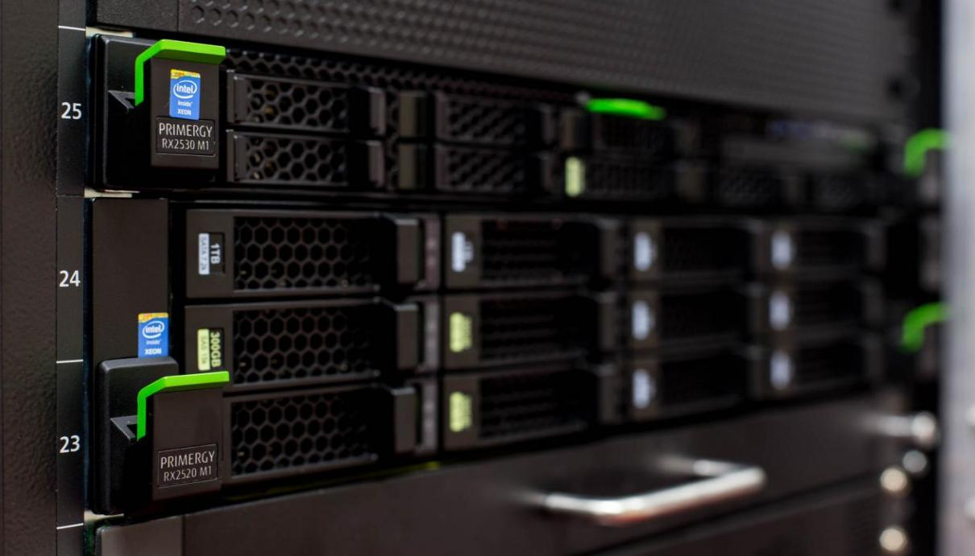

Figure 7: Hardware Server

1. **Purpose**

* Share data and complete tasks to keep your workflow running smoothly and your productivity high.
* It is important to the effectiveness of an information system because most of the software and data are accessed from hardware. Like wise, people use the hardware and many processes are carried out on the technologies established as a part of the information system.

1. **Web Server Software**
2. **Define**

A type of software that is meant to be run and maintained on a computer server.

Provides and facilitates the use of underlying server processing capability with a wide range of high-end computing applications and tasks

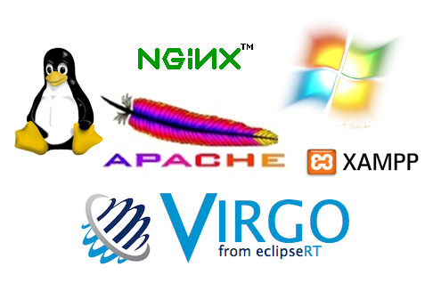

Figure 8: Web Server Software

1. **Purpose**

* On the server, operate and manage
* Publish the files to other computers
* Display website content through storing, processing and delivering webpages to users.
* Organize communication between users and the system.
* Provide resources forprogramsand how to organizetheir implementation.
* Organizeinformation storageon external memory,provide tools forsearching and accessing information.
* Check and support by software forperipheral devices to exploit them conveniently and effectively.

1. **Some Web Server Software**

**APACHE•**

The apache HTTP server Project is an effort to develop and maintain an open-source HTTP server for modern operating systems including UNIX and Windows. The goal of this project is to provide a secure, efficient and extensible server that provides HTTP services in sync with the current HTTP standards.

As of August 2018, apache estimates servers for 54.2% of active sites and 53.3% of servers. Apache runs on operating systems such as windows, linux, unix, MacOS….

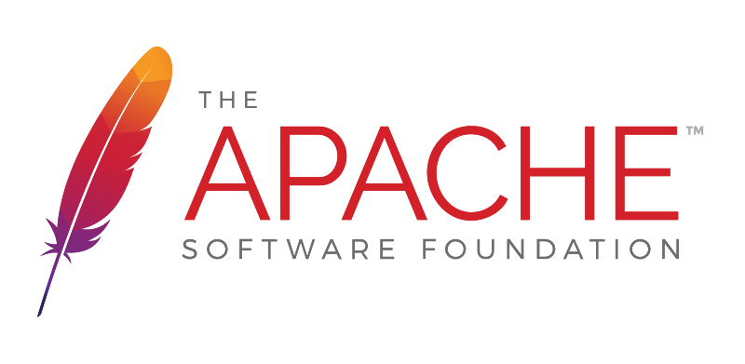

Figure 9: Apache

**MICROSOFT ISS**

IIS is a web server software package designed for Windows Server. It uses websites and other content to host the web. Microsoft's Internet Information Services provides a graphical user interface (GUI) for managing Web sites and associated users. It provides a visual medium for creating, configuring, and publishing web sites. The IIS Manager tool allows web administrators to modify site options such as default pages, error pages, logging settings, security settings, and performance optimization.

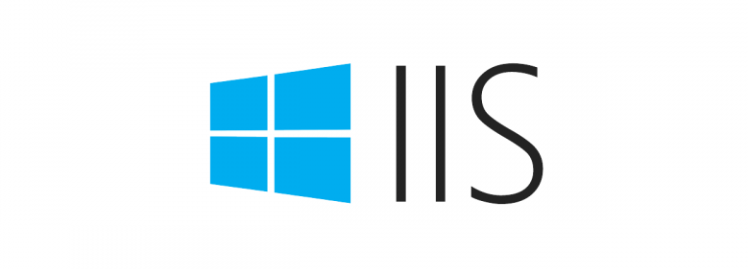

Figure 10: IIS

**TOMCAT**

Tomcat is an Apache Software Foundation application server that executes Java servers and displays web pages that include Java server page encoding. Tomcat is described as a "reference implementation" in the Java Servlet and Java Server Page specifications, and is a result of the open collaboration of developers, available in binary and source versions on the Apache Web site. Tomcat can be used individually with its own internal web server or with other web servers including Apache, Netscape Enterprise Server, Microsoft Internet Information Server (IIS) and Microsoft Personal Web Server. Tomcat requires a Java runtime enterprise environment compatible with JRE 1.1 or later.

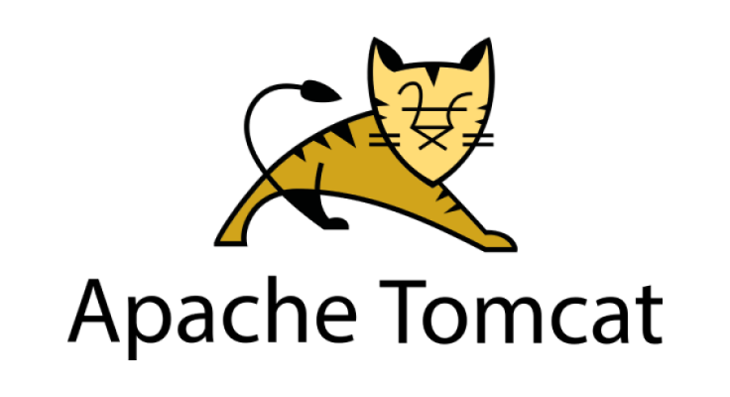

Figure 11: Tomcat

1. **Operating System**
2. **Define**

An operating system is the most important software that runs on a computer. It manages the computer's memory and processes, as well as all of its software and hardware. It also allows you to communicate with the computer without knowing how to speak the computer's language. Without an operating system, a computer is useless.

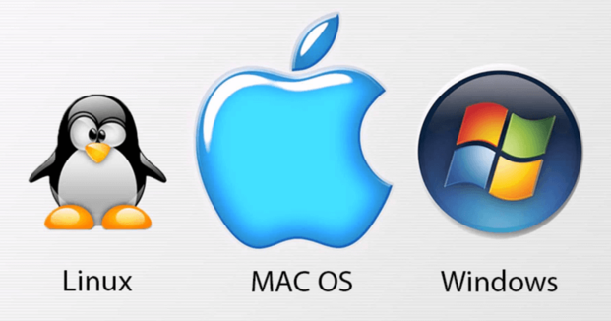

Figure 12: Operating System

1. **Purpose**

Your computer's operating system (OS) manages all of the software and hardware on the computer. Most of the time, there are several different computer programs running at the same time, and they all need to access your computer's central processing unit (CPU), memory, and storage. The operating system coordinates all of this to make sure each program gets what it needs.

Other:

* Program Execution
* Handling Input/Output Operations
* Manipulation of File System
* Error Detection and Handling
* Resource Allocation
* Accounting
* Information and Resource Protection

1. **Some Popular Operating System**

* **Windows**

Microsoft Windows is an operating system for personal and business computers. Windows system value the world of personal computers, providing a graphical user interface (GUI). Virtual memory management Windows, multitasking and support for multiple peripherals.

The Windows operating system was first released in 1980 by Microsoft, then Windows 10 (2015) and most recently Windows 11 was released on June 24, 2021.

**Advantages:** Easy-to-use interface, high stability with many diverse features for learning and working.

**Disadvantages:** Need to buy a license to install

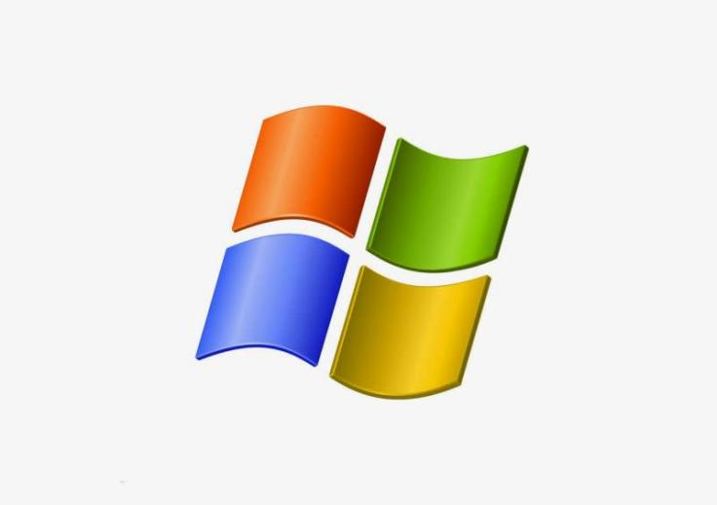

Figure 13: Windows

* **macOS**

Mac OS or OS X is the official name of the Apple Macintosh operating system. Mac OS has a graphical user interface (GUI) that uses windows. Icons and all applications that run on a Macintosh computer have a similar user interface. MacOS operating system uses high speed and is much smoother than Windows.

**Advantages:** The interface is beautiful and smooth, especially there is no cost to buy a license because it is pre-installed when buying the device.

**Disadvantages:** Picky device and many popular software still not released on this operating system.

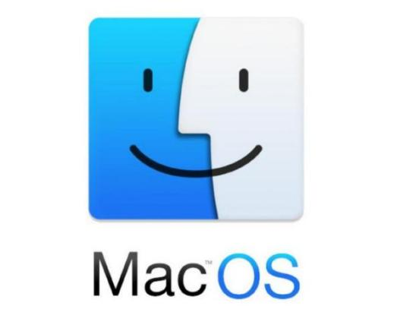

Figure 14: macOs

* **Linux**

Linux is an open source operating system that runs on a number of hardware platforms. The Linux kernel was developed primarily by Linus Torvalds and it is based on Unix. The Linux operating system is a collection of software that is a server, a programming language, and a database management system. And in particular, the operating system has extremely high security.

**Advantages:** High security, free and stable operation even on computers with weak configuration.

**Disadvantages:** Less supported software or applications on Linux and harder to use than Widows.

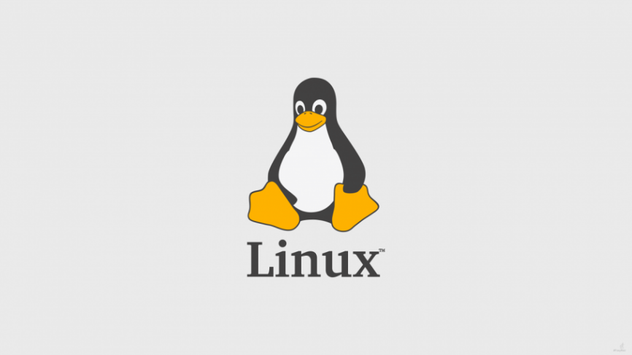

Figure 15: Linux

1. **Relationship of 4 elements**

|  |  |  |  |  |
| --- | --- | --- | --- | --- |
|  | Community Protocol | Server Hardware | Web Server Software | Operating System |
| Designing a Website | A set if specified protocol is a layered protocol implemented according to design protocol |  |  | Support website application design |
| Publishing a Website |  | Host required to upload website on the Internet | Use open source to publish websites | Any application avaliable in the system can be published and shared through the Internet |
| Accessing a  Website | Data transmission over the Internet | Support physical data exchange with other devices connected to the web | Can be accessed througth the domain name where it stores and distributes their content to user | Install web and applications from the Internet |

Table 2: Relationship of 4 element regarding design, publish and access

* **Communication protocol**
* The protocol defines rules, syntax, semantics, and synchronization of communication and can methods of error recovery. Protocols can be implemented by hardware, software or acombination of both.
* Communication protocols allow devices to communicate with one another. Devices require a transmitter and a receiver to convey and retrieve data to communicate with one another.
* **Server Hardware**
* Hardware represents all the physical things that you can touch and see which merged and built together as a single entity called a Personal Computer (PC). It can be a laptop or even yoursmart devices in this case.
* Server hardware is used to store, process, retrieve, and share data amongst computers on a network.
* **Operating System**
* Operating System (OS) is working on top of the hardware. OS is the software that brings you the interface to be able to communicate with the hardware. Well, of course, there is more than that. OS communicates with the kernel using the device drivers to send “commands” to the hardware to do the things that you want to do.
* The operating system is the heart of the computer, assigning duties to server components.
* **Web server software**
* Web Server Software is also just a software application. It is installed, and runs on a computer - the server serves as a Web Server, thanks to this program that users can access the Website information from another computer on the network (Internet, intranet). Web Server has the ability to send Web clients via the Internet environment (or Intranet) via HTTP protocol.
* The operating system, hardware, and internal data of the server are all managed by the webserver software.
* Hardware and software are interconnected, without software, the hardware of a computer would have no function. However, without the creation of hardware to perform tasks directed by software via the central processing unit, software would be useless.

1. **Website Technologies, tools and software**

**Front-end and Back-end website technologies**

Frontend and Backend are the two most popular terms used in web development. These terms are very crucial for web development but are quite different from each other. Each side needs to communicate and operate effectively with the other as a single unit to improve the website’s functionality.

1. **Front-end**
2. **Define**

The part of a website that the user interacts with directly is termed the front end. It is also referred to as the ‘client side’ of the application. It includes everything that users experience directly: text colors and styles, images, graphs and tables, buttons, colors, and navigation menu. HTML, CSS, and JavaScript are the languages used for Front End development. The structure, design, behavior, and content of everything seen on browser screens when websites, web applications, or mobile apps are opened up, is implemented by front End developers. Responsiveness and performance are two main objectives of the Front End. The developer must ensure that the site is responsive i.e. it appears correctly on devices of all sizes no part of the website should behave abnormally irrespective of the size of the screen.

1. **Front-end Languages**

The front end portion is built by using some languages which are discussed below:

* **HTML:** HTML stands for Hypertext Markup Language. It is used to design the front-end portion of web pages using a markup language. HTML is the combination of Hypertext and Markup language. Hypertext defines the link between the web pages. The markup language is used to define the text documentation within the tag which defines the structure of web pages.
* **CSS:**Cascading Style Sheets fondly referred to as CSS is a simply designed language intended to simplify the process of making web pages presentable. CSS allows you to apply styles to web pages. More importantly, CSS enables you to do this independent of the HTML that makes up each web page.
* **JavaScript:**JavaScript is a famous scripting language used to create magic on the sites to make the site interactive for the user. It is used to enhancing the functionality of a website to running cool games and web-based software.

There are many other languages through which one can do front-end development depending up on the framework for example Flutter user Dart, React uses JavaScript and Django uses Python, and much more.

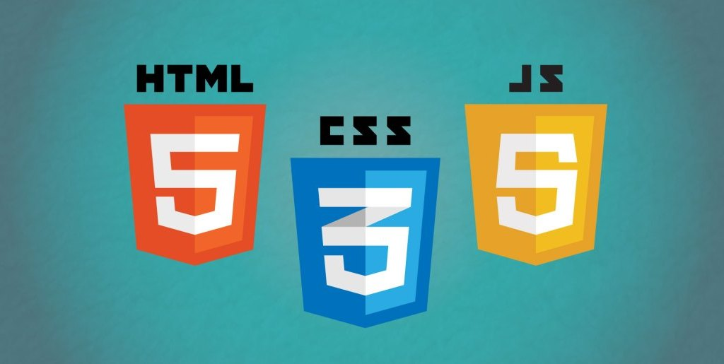

Figure 16: Front-end Languages

1. **Front End Frameworks and Libraries**

* **AngularJS:** AngularJs is a JavaScript open-source front-end framework that is mainly used to develop single-page web applications(SPAs). It is a continuously growing and expanding framework which provides better ways for developing web applications. It changes the static HTML to dynamic HTML. It is an open-source project which can be free. It extends HTML attributes with Directives, and data is bound with HTML.
* **React.js:** React is a declarative, efficient, and flexible JavaScript library for building user interfaces. ReactJS is an open-source, component-based front-end library responsible only for the view layer of the application. It is maintained by Facebook.
* **Bootstrap:** Bootstrap is a free and open-source tool collection for creating responsive websites and web applications. It is the most popular HTML, CSS, and JavaScript framework for developing responsive, mobile-first websites.
* **jQuery:** jQuery is an open-source JavaScript library that simplifies the interactions between an HTML/CSS document, or more precisely the Document Object Model (DOM), and JavaScript. Elaborating the terms, jQuery simplifies HTML document traversing and manipulation, browser event handling, DOM animations, Ajax interactions, and cross-browser JavaScript development.
* **SASS:** It is the most reliable, mature, and robust CSS extension language. It is used to extend the functionality of an existing CSS of a site including everything from variables, inheritance, and nesting with ease.
* **Flutter:**Flutter is an open-source UI development SDK managed by google. It is powered by Dart programming language. It builds performant and good-looking natively compiled applications for mobile (Ios, Android), web, and desktop from a single code base. The key selling point of flutter is flat development is made easier, expressive, and flexible UI and native performance. In march 2021 flutter announce Flutter 2 which upgrades flutter to build release applications for the web, and the desktop is in beta state.

Some other libraries and frameworks are Semantic-UI, Foundation, Materialize, Backbone.js, Ember.js, etc.

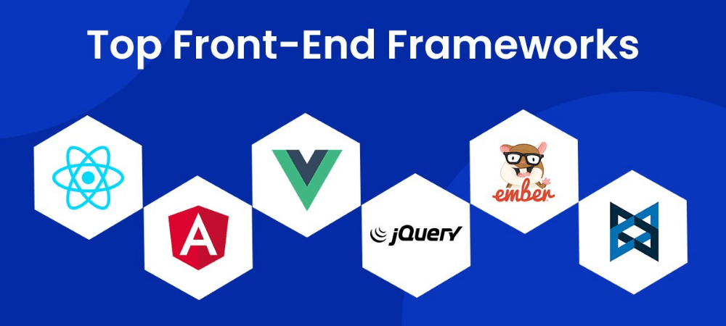

Figure 17: Front End Frameworks and Libraries

1. **Back-end**
2. **Define**

Backend is the server-side of the website. It stores and arranges data, and also makes sure everything on the client-side of the website works fine. It is the part of the website that you cannot see and interact with. It is the portion of software that does not come in direct contact with the users. The parts and characteristics developed by backend designers are indirectly accessed by users through a front-end application. Activities, like writing APIs, creating libraries, and working with system components without user interfaces or even systems of scientific programming, are also included in the backend.

1. **Back-end Languages**

The back end portion is built by using some languages which are discussed below:

* **PHP:** PHP is a server-side scripting language designed specifically for web development. Since PHP code executed on the server-side, so it is called a server-side scripting language.
* **C++:** It is a general-purpose programming language and widely used nowadays for competitive programming. It is also used as a backend language.
* **Java:** Java is one of the most popular and widely used programming languages and platforms. It is highly scalable. Java components are easily available.
* **Python:** Python is a programming language that lets you work quickly and integratesystems more efficiently.
* **JavaScript:** JavaScript can be used as both (front end and back end) programming languages.
* **Node.js:** Node.js is an open-source and cross-platform runtime environment for executing JavaScript code outside a browser. You need to remember that NodeJS is not a framework, and it’s not a programming language. Most people are confused and understand it’s a framework or a programming language. We often use Node.js for building back-end services like APIs like Web App or Mobile App. It’s used in production by large companies such as Paypal, Uber, Netflix, Wallmart, and so on.

1. **Back-end Frameworks**

The other back-end program/scripting languages are C#, Ruby, REST, GO, etc

* **Django:** Django is a high-level framework that is developed with the notion of ‘batteries included’. This means that almost everything any developer would require is already included. Django is the best back-end framework for Python as it is highly customizable and scalable. It has extensive community and documentation and facilitates the best web application development framework. The well-known websites created using Django Python are Mozilla, Disqus, Pinterest, National Geographic, to name a few.
* **Laravel:** Laravel is one of the best backend framework for web development. It has excellent language construction, the capability to suit giant groups and the effectiveness of its advanced toolbox. Based on PHP language, Laravel follows the MVC design architecture. With expressive, elegant syntax, Laravel allows web developers to be flexible and creative while taking care of the background details, unlike other frameworks.
* **CakePHP:** CakePHP is a popular web app development framework introduced in 2005 for PHP development. Since its inception, it has progressed and is now termed as a contemporary web tool, allowing its developers to develop apps quickly. This makes it a preferable choice for developing both big and small web applications. It has no complex configuration to start and renders complete security.
* **SpringBoot:** Spring Boot is one of the widely used JS backend frameworks. This is an inversion of the control container and an application framework for the Java platform. Its core characteristics can be exercised by any Java app, but there are many extensions for developing websites.
* **Phoenix:** Phoenix is the best back end framework that is written in a functional programming language named Elixir. It functions with Erlang’s Virtual Machine and Phoenix uses a server-side MVC pattern.

1. **Relationship between front-end and back-end**

* Frontend and backend development are quite different from each other, but still, they are two aspects of the same situation. The frontend is what users see and interact with and the backend is how everything works.
* The frontend is the part of the website users can see and interact with such as the graphical user interface (GUI) and the command line including the design, navigating menus, texts, images, videos, etc. Backend, on the contrary, is the part of the website users cannot see and interact with.
* The visual aspects of the website that can be seen and experienced by users are frontend. On the other hand, everything that happens in the background can be attributed to the backend.
* Languages used for the front end are HTML, CSS, JavaScript while those used for the backend include Java, Ruby, Python, .Net.

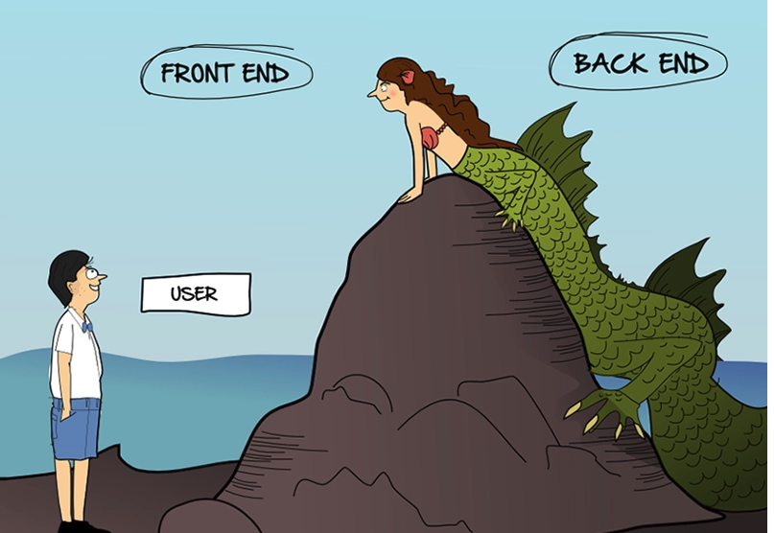

Figure 18: Relationship between Front-end and back-end

1. **Distinguish Server-side endering and Client-side rendering**
2. **Client-side rendering**

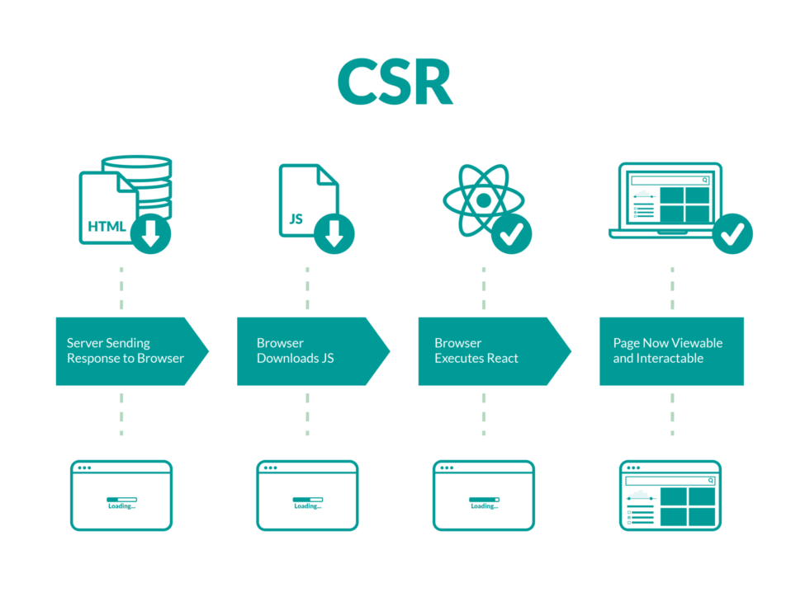

Figure 19: Client-side rendering

This type of application rendering is considered to be a new approach and widely used for developing recently. This is rendering of pages just in the client’s browser. Content from the browser is rendered using JavaScript and libraries like Angular, VueJS, ReactJS.So how does client-side rendering proceed? Let’s have a deep look at this process:

* Sending a request for information to a website using a browser;
* Content Delivery Network can be used to serve static HTML, CSS, and supporting files to the user;
* When the user sees the process of loading the page, it means that the browser downloads the HTML and JS;
* Then the browser makes API requests using the HTTP request to show the dynamic content and renders it to the final aspect;
* After the server responds, the final look of content is rendered using DOM processing in the client’s browser.
* Receiving data, templating, and routing are processed on the client-side, not on the server. This type of rendering is hardly supported on mobile devices.

**Client-side rendering the pros and cons**

As client-side rendering is just one of the possible ways of building software, it has its advantages and disadvantages. It is important to define if this type is suitable for your project from the very beginning to develop a high ranked app.

**Pros:**

* Fast rendering process
* Simple navigation
* Lower server load
* Relevant for web applications

**Cons:**

* Slow loading for the first time on the website
* Need for external framework libraries
* A weak side of SEO
* Some or all content is not included

1. **Server-side rendering**

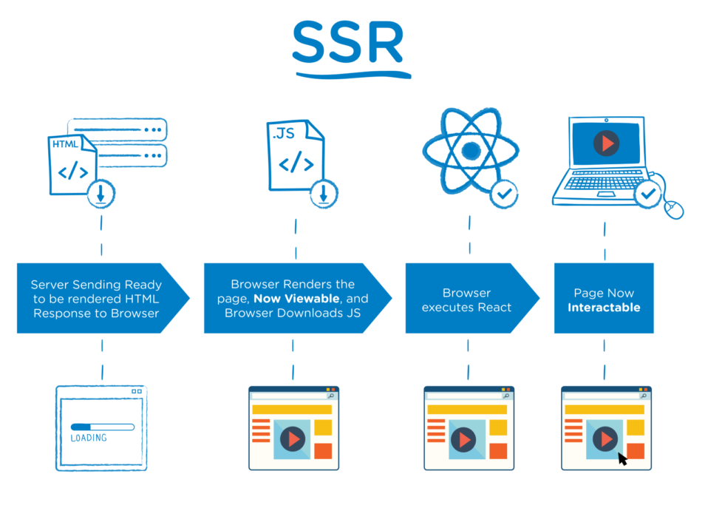

Figure 20: Server-side rendering

At the server-side type of rendering pages, a response to the user’s request is generated the whole HTML code of the page. It excludes the need for additional data requests from the client-side as the server-side takes all the activity over before sending a response. This approach gives a quick initial load. Server-side rendering helps to avoid the sending of a huge amount of HTML to the user that leads to less interaction time. This type of rendering implies sending only text and links to the user. This approach perfectly suits different devices and networks and gives opportunities for browser optimizations.

Server-side rendering is considered to be a traditional way of rendering pages. So the main features of processing the page at server-side type are:

* Sending requests to a website by the user.
* The server checks the resource and prepares the HTML content.
* This compiled HTML is sent to the client’s browser for further rendering and display.
* The browser downloads the HTML content and makes the page visible to the user.
* The browser then downloads the Javascript libraries, and it makes the page interactive.

You may wonder if server-side rendering is suitable and enough for your future software. It depends on its type and features this application will contain. There are many discussions about applying server-side vs client-side but you have to remember that some pages can be rendered by the server, and some not.

**Server-side rendering the pros and cons**

As we already defined that server-side type can not suit all web solutions, consequently there are some causes of that. It is high time to mention the key advantages and disadvantages of server-side rendering.

**Advantages:**

* Quick initial access – at server-side type, pages are rendered very fast for interaction with users, even if the speed of your internet provider is not high. This function gives a great user experience;
* High level of SEO search – the content of the pages get indexed more quickly than client-side type;
* Excellent static site.

**Disadvantages:**

* The transition from one page to another takes more time that SSR, especially if the amount of data is big; it happens because of double rendering on both sides – servers and clients;
* The vulnerability that gives more chance for a surface attack;
* Complicated caching – server-side rendering gets more complex cache than client-side rendering;
* The cost of the server is basically higher because it needs to be more powerful than CSR;
* Higher latency – if there are too many users on the website who make the same requests, the traffic speed can be very slow, the time counts in milliseconds, so it can be a crucial con.

1. **Website Technologies**
2. **Front-end ( Most popular frame today )**

* **AngurlaJs**

**Define**

AngularJS is an open-source web application framework. It was originally developed in 2009 by Misko Hevery and Adam Abrons. It is now maintained by Google.

AngularJS is a structural framework for dynamic web applications. It lets you use HTML as your template language and lets you extend HTML's syntax to express your application components clearly and succinctly. Its data binding and dependency injection eliminate much of the code you currently have to write. And it all happens within the browser, making it an ideal partner with any server technology.

**Advantages:**

* It provides the capability to create Single Page Application in a very clean andmaintainable way.
* It provides data binding capability to HTML. Thus, it gives user a rich and responsive experience.
* AngularJS code is unit testable.
* AngularJS uses dependency injection and make use of separation of concerns.
* AngularJS provides reusable components.
* With AngularJS, the developers can achieve more functionality with short code.
* In AngularJS, views are pure html pages, and controllers written in JavaScript do the business processing.
* On the top of everything, AngularJS applications can run on all major browsers and smart phones, including Android and iOS based phones/tablets.

**Disadvantages:**

* Not Secure − Being JavaScript only framework, application written in AngularJS are not safe. Server side authentication and authorization is must to keep an application secure.
* Not degradable − If the user of your application disables JavaScript, then nothing would be visible, except the basic page.

**Brands that use AngurlaJs:** Samsung, Paypal, Forbé, Gmail, …

* **Veu.js**

**Define**

Vue.js is a “new, good” Framework for building single-page applications based on the JavaScript language. It has been designed to extend capabilities and easily integrate with other libraries.

In essence, Vue.js uses MVC (Model-View-Controller) architecture and can be used synchronously with different architectures like CBA (Component-Based Architecture).

Interoperability with various available frameworks has made Vue very popular in the web development ecosystem.

**Advantages:**

* Libraries and tools to support many
* Low storage requirements
* Simple, easy to learn
* Full Documentation
* Components and reusability
* Component Based Architecture (CBA)
* Easy to read, easy to maintain
* Adaptability, comfort in coding

**Disadvantages:**

* Language barrier and limited community (mostly Chinese)
* Loosening the integration leads to anything usable, causing errors
* Lack of financial support for large-scale projects due to not being able to equal Angular or React
* Limited resources due to being young

**Companies that use Veu.js:** Google, BMW, Louis Vuitton, Adobe, Nintendo

* **React.js**

**Define**

React is a library for building composable user interfaces. It encourages the creation of reusable UI components, which present data that changes over time. Lots of people use React as the V in MVC. React abstracts away the DOM from you, offering a simpler programming model and better performance. React can also render on the server using Node, and it can power native apps using React Native. React implements one-way reactive data flow, which reduces the boilerplate and is easier to reason about than traditional data binding.

**Advantages:**

* Uses virtual DOM which is a JavaScript object. This will improve apps performance, since JavaScript virtual DOM is faster than the regular DOM.
* Can be used on client and server side as well as with other frameworks.
* Component and data patterns improve readability, which helps to maintain larger apps.

**Disadvantages:**

* Integrating Reactjs into traditional MVC frameworks requires reconfiguration.
* React is quite heavy compared to other frameworks React is similar in size to Angular (About 35kb compared to 39kb of Angular).
* Whereas Angular is a complete framework Difficult to access for newbies to learn Web
* Reactjs only serves the View layer

**Application that works on React.js:** Facebook, Instagram, Netflix, Discord, …

1. **Back-end**

* **PHP**

**Define**

PHP is an acronym for the phrase Hypertext Preprocessor. Is a programming language commonly used to develop applications. Anything related to server writing, open source or general purpose. In addition, it is very suitable for web development and can be easily embedded into HTML pages.

**Advantages of PHP :**

* Most important advantage of PHP is that it’s open source and free from cost.
* It is platform independent.
* It helps in reusing an equivalent code and no got to write lengthy code and sophisticated structure for event of web applications.
* It helps in managing code easily.
* It has powerful library support to use various function modules for data representation.
* PHP’s built-in database connection modules help in connecting database easily reduce trouble and time for development of web applications and content based sites.
* Flexibility makes PHP ready to effectively combine with many other programming languages in order that the software package could use foremost effective technology for every particular feature.

**Disadvantages of PHP :**

* It is not suitable for giant content-based web applications.
* It has a weak type, which can cause incorrect data and knowledge to user.
* PHP frameworks got to learn to use PHP built-in functionalities to avoid writing additional code.
* Using more features of PHP framework and tools cause poor performance of online applications.
* PHP don’t allow change or modification in core behavior of online applications.
* The PHP frameworks aren’t equivalent in behavior so does their performance and features.
* PHP lacks debugging tools, which are needed to look for errors and warnings.
* It’s highly tough to manage because, it’s not competent modular.
* **ASP.NET**

**Define**

ASP in full is Active Server Pages, and .NET stands for Network Enabled Technologies. ASP.Net is a platform for web development, first released and offered by Microsoft in 2002. The platform is used to create web-based applications.

**Advantages:**

* The .NET framework provides a consistent, object-oriented programming environment.
* It promotes the safe execution of code.
* Eliminates the performance problems of scripted or interpreted environments.
* It minimizes software deployment and versioning conflicts.
* A consistent experience for both developers and users across various types of Windows-based and Web-based applications on multiple devices.
* Communication built on the industry standards to ensure that code based on the .NET Framework can integrate with any other code.

**Disadvantages:**

* It doesn’t support many platforms like Java.
* It doesn’t support many CMS.
* It does not provide the same JavaScript on the server and client-side which could be easy for coding.
* **JSP/Java**

JavaServer Pages (JSP) is a technology for developing web pages that support dynamic content which helps developers insert java code in HTML pages by making use of special JSP tags, most of which start with <% and end with %>.

Using JSP, you can collect input from users through web page forms, present records from a database or another source, and create web pages dynamically.

**Advantages :**

* Output of JSP page is standard HTML and is therefore compact and universally readable in any browser.
* It is HTML friendly, supports Java code.
* Easy language & Tags.
* JSP pages easily combine static templates, including HTML or XML fragments, with code that generates dynamic content.
* JSP tags for invoking JavaBeans components manage these components completely, shielding the page author from the complexity of application logic.
* Developers can make logic changes at the component level without editing the individual pages that use the logic.

**Disadvantages :**

* Output is HTML which is not rich in features.
* Difficult to debug/trace errors since JSP pages are translated into servlets and compiled.
* JSP pages require more time when accessed for the first time as they are to be compiled on the server.
* Database connectivity is not as easy as it should be. Most of the servlet engine vendors do not support connection pooling natively
* Numerous syntax related issues with JSP programming.

## **Relationships between front-end, back-end website technologies , application layers and presentation layer.**

* **The capabilities and relationships between front-end and back-end website technologies**

In online applications, the phrase front end refers to code that is performed in the browser, whereas the term back end refers to code that is executed on the webserver. The front end is frequently referred to as the client-side, whereas the back end is referred to as the serverside. The data required to run a website will be stored on servers, the application, and a database in the back-end development. A serverside language is used to allow the server, application, and database to all work and communicate with one another. MySQL works by first building a database for storing and modifying data. Clients can then make requests by inputting certain SQL statements into MySQL, and the server's application will respond with the desired information and display it on the client's side browser. The language, database, security, and backup aspects of a website's back-end development will be addressed.

* **How these relate to presentation and application layers**

When data is transferred over the HTTPS protocol on a browser, it is encrypted to protect it from those attempting to hack and intercept it as it travels over the internet. When this happens, the HTTPS protocol is used to protect credit card information between two devices that are communicating with each other, such as when someone buys something off the internet. The FTP protocol is used in the application layer to transmit files between the server and the client via a network, such as when uploading files to a webserver to host a website. The mail protocol is on the application layer and employs the SMTP protocol to send emails over the internet, while the POP3 protocol is used to receive emails. The Telnet protocol is also on the application layer and is used to remotely access a device.

|  |  |
| --- | --- |
| Front-end and presentation layer | Back-end and presentation layer |
| Create user interface, presentation classes.  Data transfer and reception from the presentation layer  Data transfer to the application layer  Translation  Data should be sent to the application layer. | The program is interacted with by the users.  The operation of the website  Collect data |

Table 3: Layer

1. **Discuss the differences between online website creation tools and custom-built sites with regards to design flexibility, performance, functionality, User Experience (UX) and User Interface (UI)**

There are some ways for you to buit a website:

* **CMS**

A content management system (CMS) is software that enables anyone to create, manage, and modify information on a website without the need for specialized technical knowledge. A content management system (CMS) is a platform that allows you to develop a website without having to write all of the code from scratch (or even know how to code at all). Rather than creating your system to create web pages, store images, and do other tasks, the content management system handles all of the basic infrastructures for you, enabling you to focus on more forward-facing components of your website.

* **Website Builder**

A website builder is a platform or tool that allows you to create a website fast and simply. These site builders assist you in developing your online presence, a unique.com (or.whatever) furnished with your brand's own elements, content, and offers, suited to your specific business goals. You may work on it whenever and wherever you choose (as long as you have an internet connection), allowing you to develop on the fly. Most online builders provide hosting services, so you won't have to jump through any additional technical hoops. This is a simple choice for beginners.

* **Online Tools**

Online theme building tools: Most themes are constructed such that what you see is precisely what you get. The colors and maybe the fonts can be modified, but the arrangement is set in stone. If you really enjoy the style and design and don't want to change it, a template may be a wonderful choice for you. Start-up companies and do-it-yourselfers usually want a website up and operating quickly and on a limited budget. Website styles and platforms such as WordPress and WIX are commonly plug-and-play.

* **Custom-built**

Custom-built websites are processes that produce a user interface that is unique to the website. Moreover, the experience in response to user inputs (any action by the user) which designers can use to produce an array of outputs. Above all, custom-built websites will provide your own “built from the ground-up website” and provide your users with a much more unique experience.   
Although custom website designs will provide you with more flexibility, they will take more time to build as well as more time spent managing them.

Here, we will only talk about two main way that online tools and custom-built

|  |  |  |
| --- | --- | --- |
|  | Online tools | Custom-built |
| Design flexibility | Customization restrictions  Save time  Cheap | Adapt to the needs of the user  It takes a lot of development  time  Flexible  Expensive |
| Performance | Not entirely responsive on all devices | Responsive on all devices  Easy yo update  Works on all browser |
| Functionality | Some templates were not well performed or maintained  Limited functionality | Without limits  Optimized for SEO |
| User Experience(UX) | Not Impressed | Interesting Impression |
| User Interface (UI) | Simple, common like other online created sites | Unique, based on the designer’s idea |
| Advantages | Many Modules, Tools help web developers solve all problems in a short time  Templates are ideal for those on a tight budget. There is a lower initial cost | The website will have a one-of-a-kind design that incorporates the firm's branding and is tailored to the demands of your organization.  A personalized website is customizable to the demands of your business.  The site has been tested to operate in all browsers.  The site will be constructed in such a way that it will be search engine friendly. |
| Disadvantages | Because many other businesses may be utilizing the same template, your site may not stand out as much.  A template site's support system is unlikely to be as good as that of a custom-built site  Any customized or additional technologies cannot be implemented as templates on a structured system.  Some templates are not optimized for search engines.  It is possible that not all gadgets will operate perfectly | A customized website costs more than a template.  A bespoke site takes longer to construct than a template site. |

Table 4: Compare Online tool and custom-built

1. **Analyze the effect of search engines on website performance**
2. **Definition of Search engine**

Search engine is a service that allows Internet users to search for content via the Word Wide Web. A user enters keywords or key phrases into a search engine and receives a list of Web content results in the form of websutes, images, video or other online data.

1. **Definition of SEO**

Search engine optimization is the process of growing the quality and quantity of web traffic by increasing the visibility of a website or a web page to users of a web search engine. SEO refers to the improvement of unpaid result and excludes direct traffic and the purchase of paid placement. Additionally, it may target different kinds of searches, including image, video, academic, news search and industry-specific vertical search engines. Promoting a site to increase the number of black links, or inbound links, is another SEO tactic.

1. **Technical solution to improve website index based on SEO**

**Publish Relevant Content:** Quality content is the number one driver of search engine rankings and there is no subsitute for great content. Quality content created specifically for your intended user increase site traffic, which improves your site’s authority and relevance.

**Update Content Regularly:** Regularly updated content is viewed as one of the best indicators of a site;s relevancy, so be sure to keep it fresh. Audit your content on a set schdule and make updates as needed.

**Have a link-worthy site:** Focus on creating relevant links within the text. Instead of having “click here” links, try writting out the name of the destination. “Click here” has no search engine value beyond the attached URL, whereas “Michigan Tech Enterprise Program” is rich with keywords and will improve your search engine rankings as well as the ranking of the page you are linking to.

**Use alt tags:** Always describe visual and video media using alt tags, or alternative text descriptions. They allo search engines to locate your page, which is crucial-especially for those who use text-only browsers or screen readers.

1. **The influence of web devlopment technologies and frameworks on web design and management**
2. **Some web development technologies and frameworks**

**Bootstrap**

An open-source CSS framework, Bootstrap is available for free and focused on delivering responsive, mobile-first front-end web development. It contains CSS and (if you choose) JavaScript based design templates for everything from typography, forms, CTA or other buttons, website navigation and other critical components of a stellar UI.

**Angular JS**

One of the most popular and well-known frameworks – Angular.js comes from the digital giant of the day, Google. It is essentially a JavaScript open-source framework that can help you make single web-page applications using an MVC (Model-Controller-View) architectural pattern. It is not really a full stack framework, but you can consider it as a front-end framework which is great for handling your WebPages.

**React.Js**

An open-source JavaScript library, React.js is maintained by Facebook while being supported by a massive community of [react developers](https://relevant.software/react-js-development-services/). Though it is an e-commerce website development tool, React.js is particularly useful in the development of user interface for the website applications.

What is more interesting is that React is soon going to launch React Fibre – a reimplementation of ReactJs’ core algorithm. This is precisely why it is of absolute importance to include React.js in your list of tools when you are out to build a stellar e-commerce website.

**Node.js**

Node.js is decidedly the best when you are looking to build a lightweight, yet highly efficient website. It is uncanny how perfectly well it works with real-time applications that have a huge amount of data running through on distributed devices. Node.js is more than a mere framework. It has the ability to ensure scalability and fast network applications as they are capable of dealing with multiple applications at the same time without compromising on performance.

**Spring**

Coming from Pivotal Software, Spring is the most popular app development framework for enterprise Java. The framework is popular among a huge section of developers globally for creating high performance and strong web apps. The framework is particularly known for creating JVM-based systems and applications that are simple, portable, fast, and flexible. The framework uses Java and has been used for creating websites like Mascus and Allocine.

**Jquery**

This one is more of a JavaScript library that is designed to simplify HTML DOM tree traversal and manipulation in addition to event handling, CSS animation, and Ajax. It is a free, open source software that uses the permissive MIT License. Its syntax is designed particularly to make it easier to navigate a document, choose DOM elements, create animations, handle events and develop Ajax applications. jQuery enables developers to create plugins on top of the JavaScript library. The core features here including DOM element selections, traversal and manipulation which are further enabled by the selector engine Sizzle has led to the creation of a unique style of programming combining algorithms and DOM data structures.

And so on

1. **The impact of common web development technologies and framework with regard to website design, functionality and management.**

Frameworks are straight forward representation of a programming language, as they are easy to learn and get the job done in no time. However, excessive use of these development tools often eradicates one’s chances of getting the real deal-learning the language with a much more comprehensive overview. Think of it as going to college, only you never really get the thrill of it because you were homeschooled.

The fact that most programmers consider frameworks the quickest means to understanding a programming language is often than not a far-fetched idealism. Because most times, they tend to abandon the task of learning how a languages works once the job is done and completed. We all are a victim of this at same point, so there is no denying that.

1. **System analys and evalution**

* **Technology**
* Javascript
* Bootstrap
* HTML5
* CSS
* **Require Function**

1. **Require Function**

* View products, product details
* Search products, product categories
* Add products to cart and purchase, update and delete product
* Send feedback, reviews, contact
* View articles about newly discovered ancient relics
* Must have header to contain categories like main page, product page, blog, contact page
* Must have footer to contain information as well as links to social sites

1. **System Design**
2. **User Interface**

* **Header ( For all page )**

Header: A section containing information about the pages of a website, helping customers to cover the main parts of the website including such as product pages, blog pages, contact pages, etc.

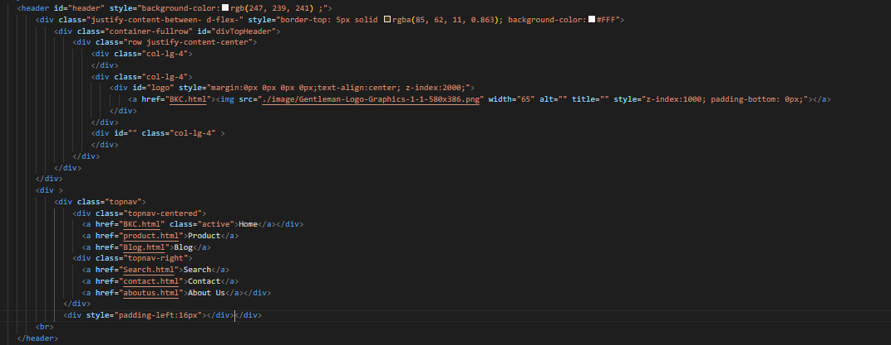

Figure 21: Header Code



Figure 22: Header

* **Footer ( For all page )**

Footer: A section containing information about the business, contact information, social links

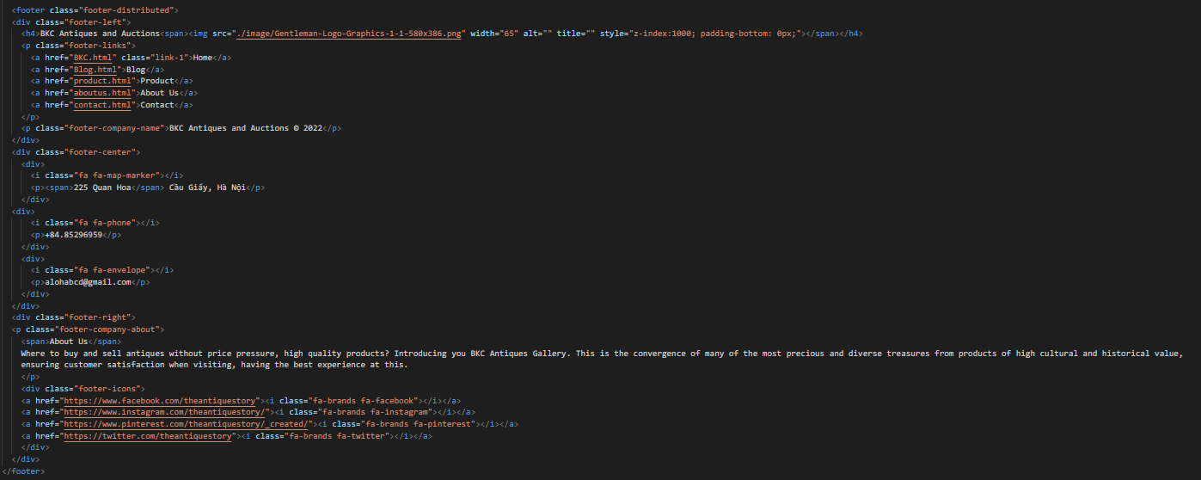

Figure 23: Footer Code

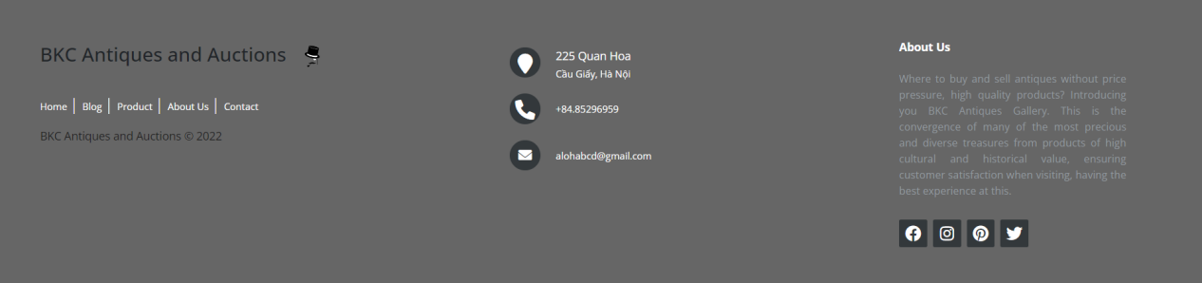

Figure 24: Footer Code

* **Home Page**

Basically, the homepage will contain all the information of other pages such as product pages, blogs, etc. to help customers get an overview of the website.

**Home Page’s Banner**

Banner will be a few images to highlight the website, can be images of products or images related to the website (here is an image related to antiques).

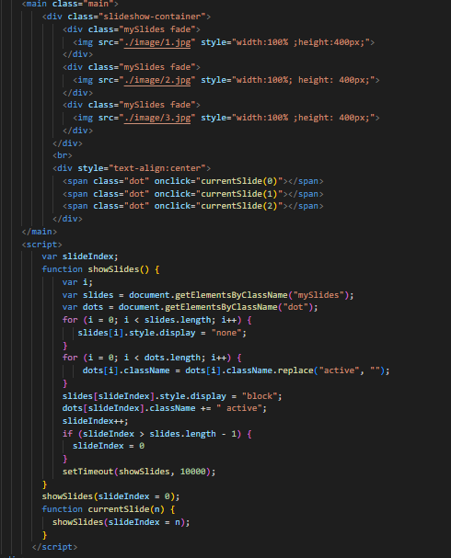

Figure 25: Home Page’s Banner Code



Figure 26: Home Page’s Banner

**Home Page’s Product Category**

In the home page, instead of displaying the products, I will only put the product categories so that customers can see how many types of products are available, both covering the information and not getting confused eye

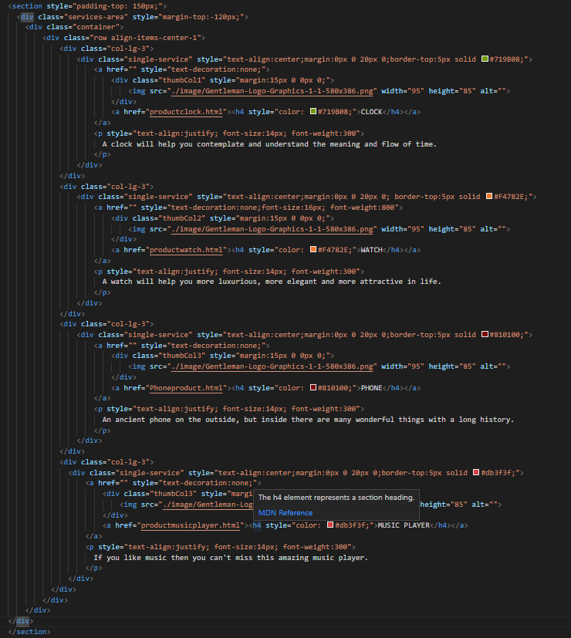

Figure 27: Home Page’s Product Category Code

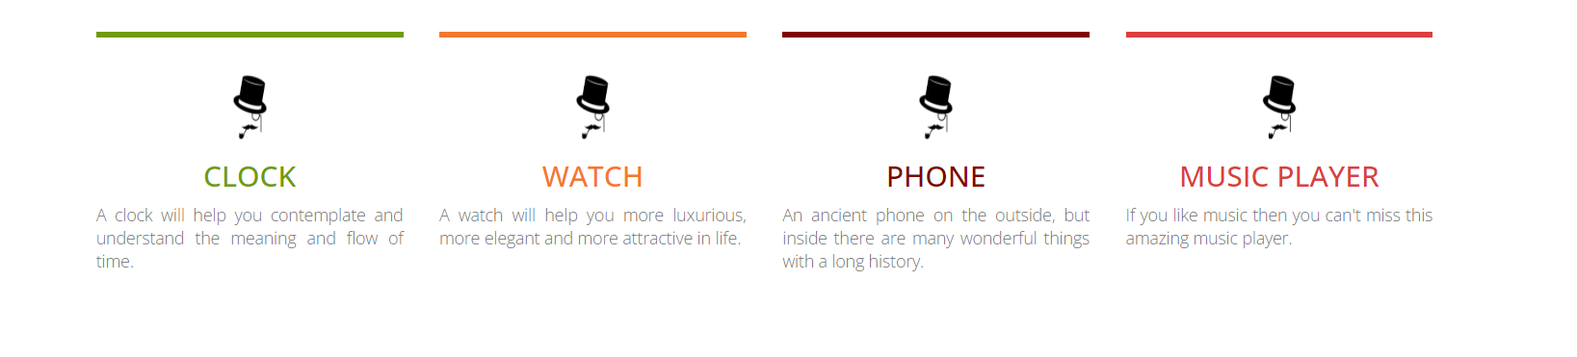

Figure 28: Home Page’s Product Category

**Home Page’s About Us**

In the homepage, there will be a section related to the About Us page, instead of displaying information or articles, customers will be left with a link to the About Us page so that customers can learn about BKC Antiques.

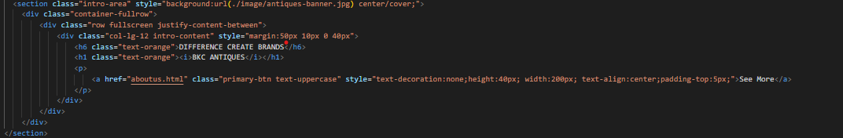

Figure 29: Home Page’s About Us Code



Figure 30: Home Page’s About Us

**Home Page’s Blog**

Similar to the About Us section, the Blog will also be a link to the Blog page for customers to view and learn about antique articles.



Figure 31: Home Page’s Blog Code

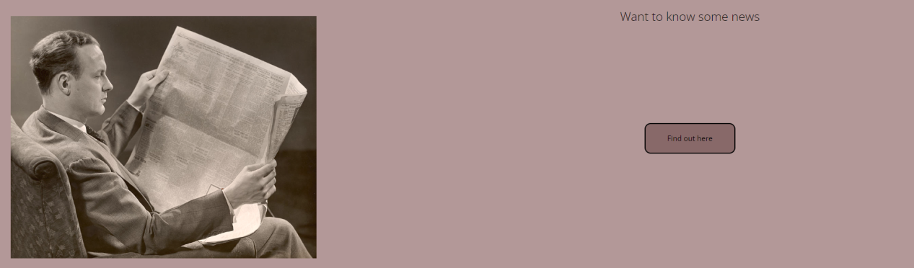

Figure 32: Home Page’s Blog

**Total Home Page**

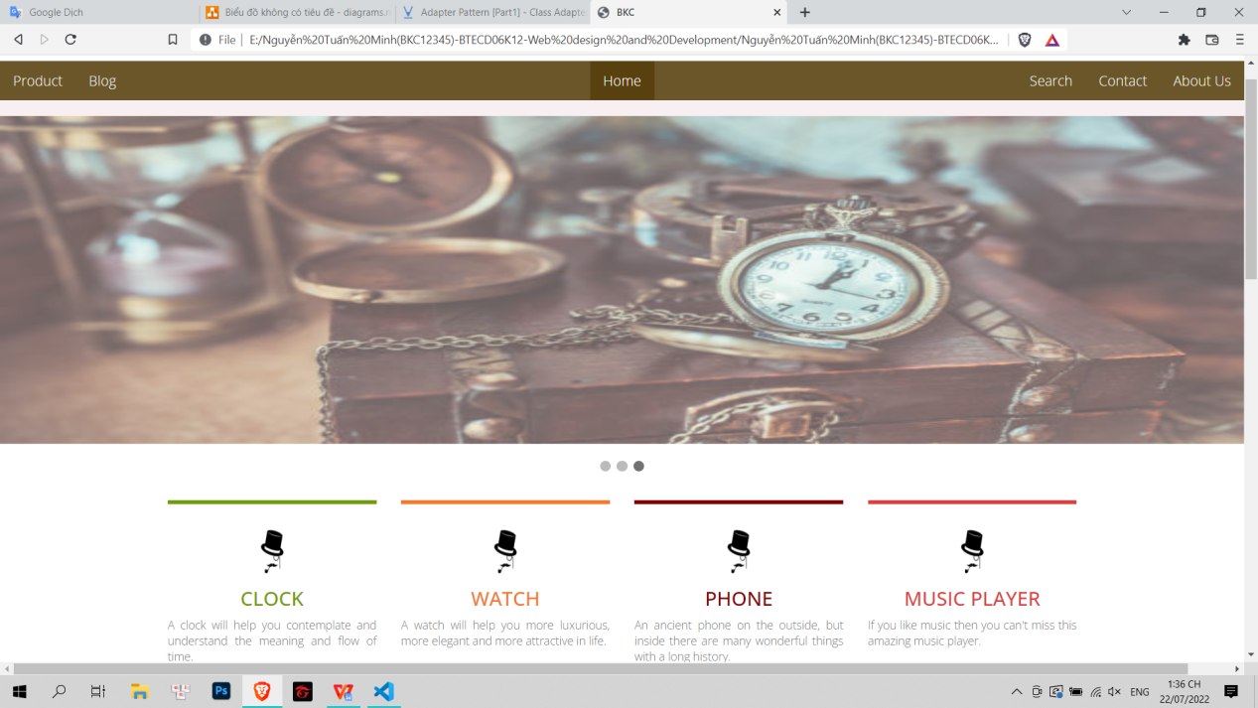

Figure 33: Home Page(1)

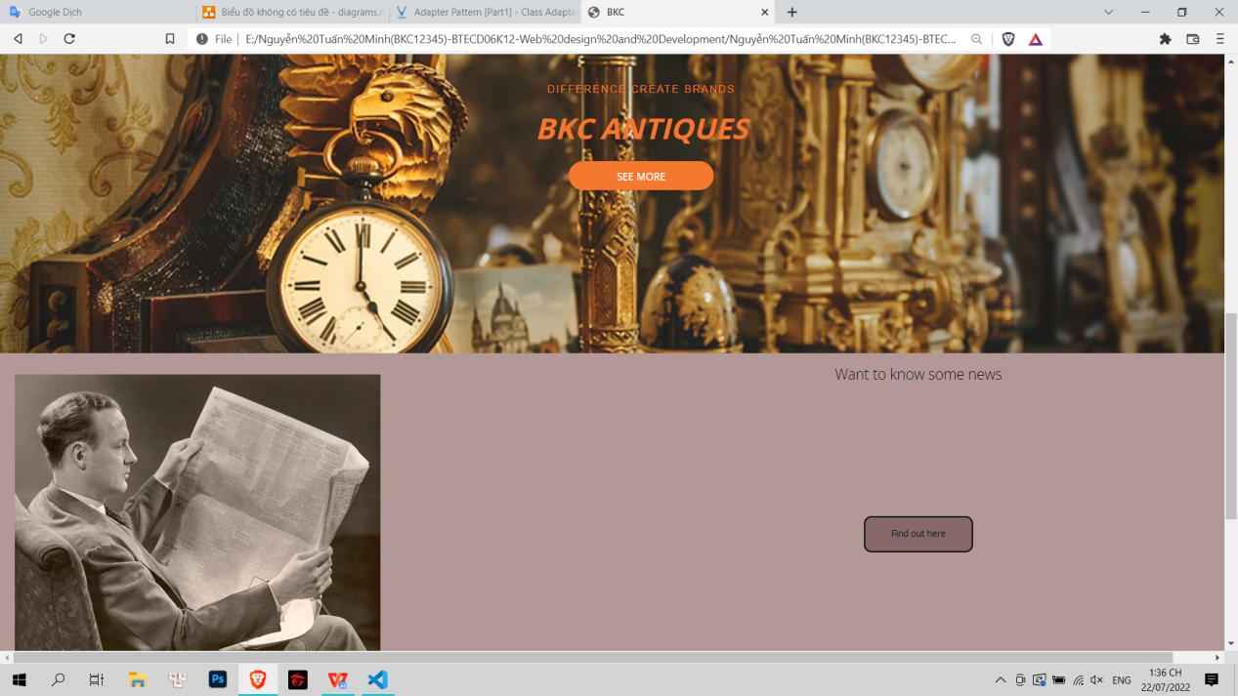

Figure 34: Home Page(2)

* **Product**

The product page is the page that contains all the products of the website, besides the page also contains the product category.

**Product Category**

The product category helps customers know how many types of products are available at BKC

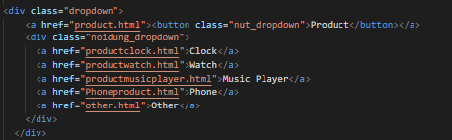

Figure 35: Product Category code

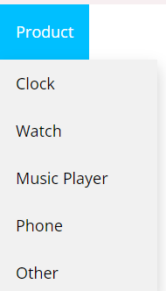

Figure 36: Product Category

**Product**

Contains product name as well as product image

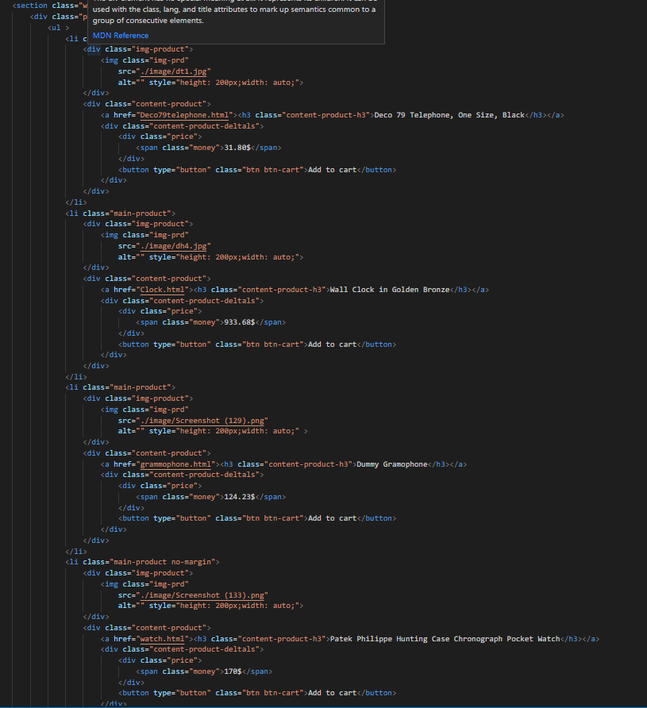

Figure 37: Product Code

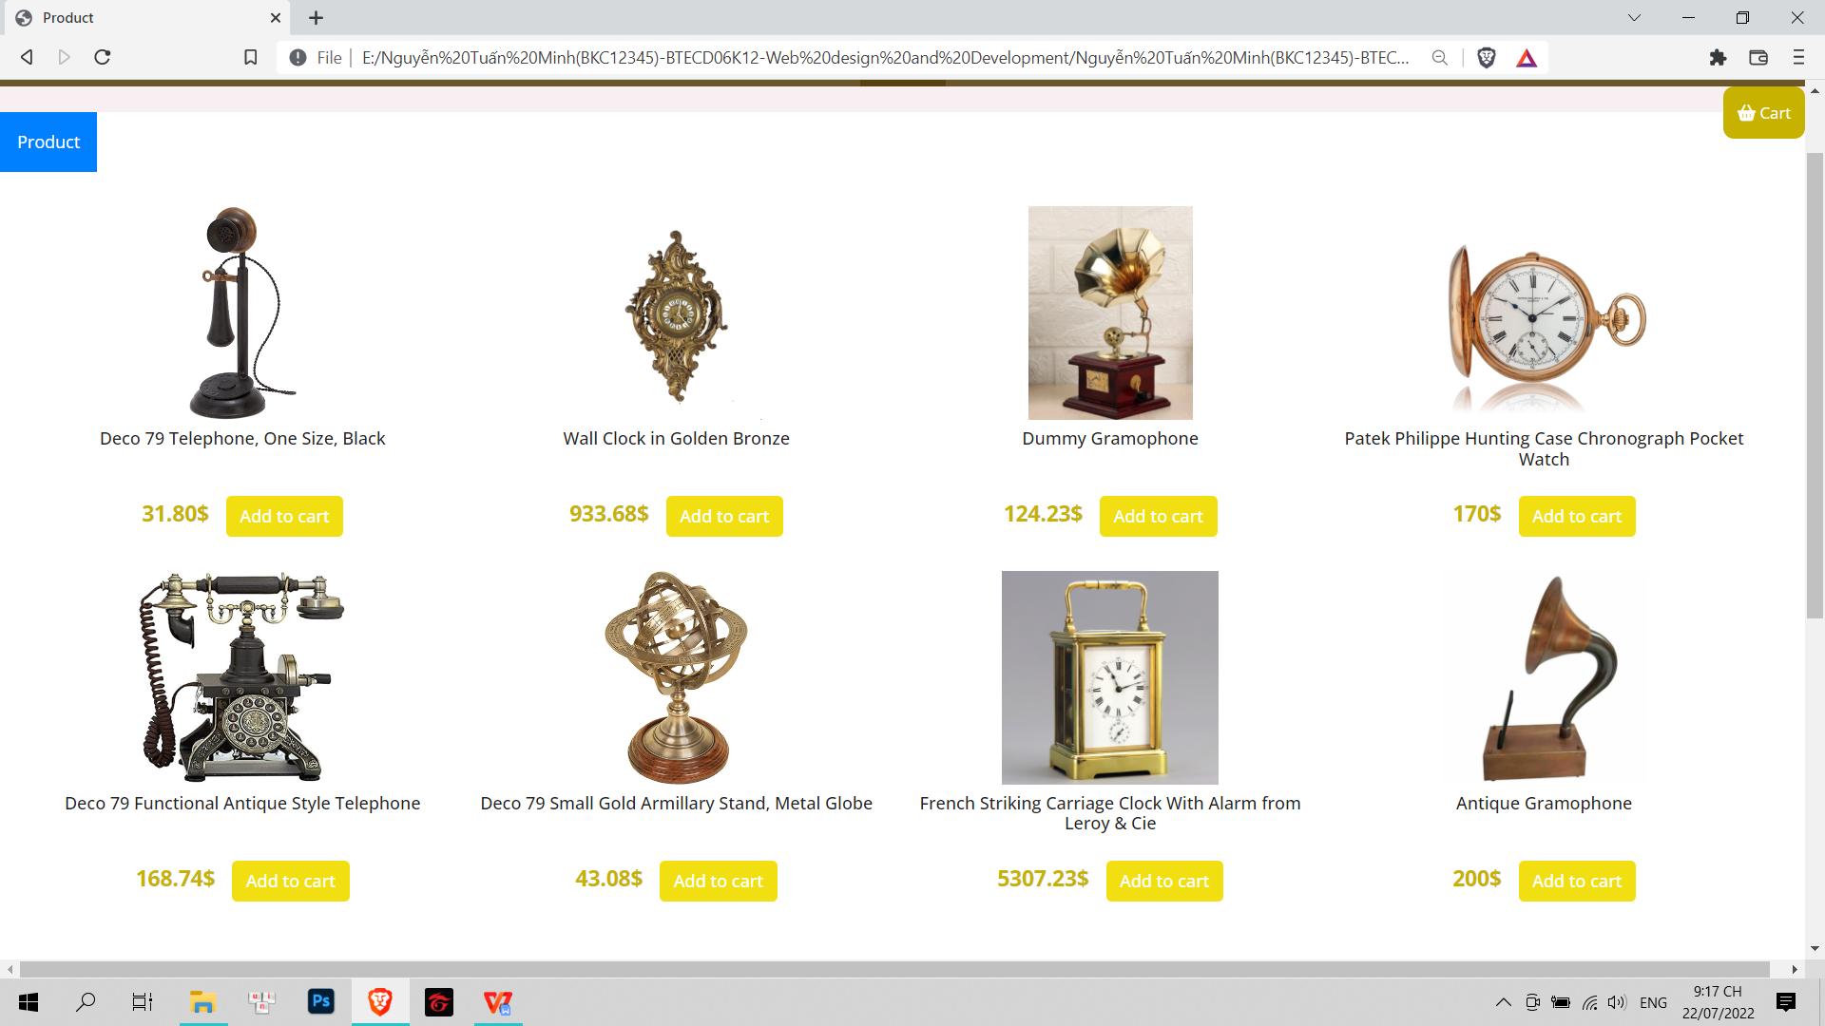

Figure 38: Product Page

**Total Product Page**



Figure 39: Product Page

* **Product Detail**

The product detail page will display the product's information (origin, material, structure, ...)

Example (Deco 79 Telephone)

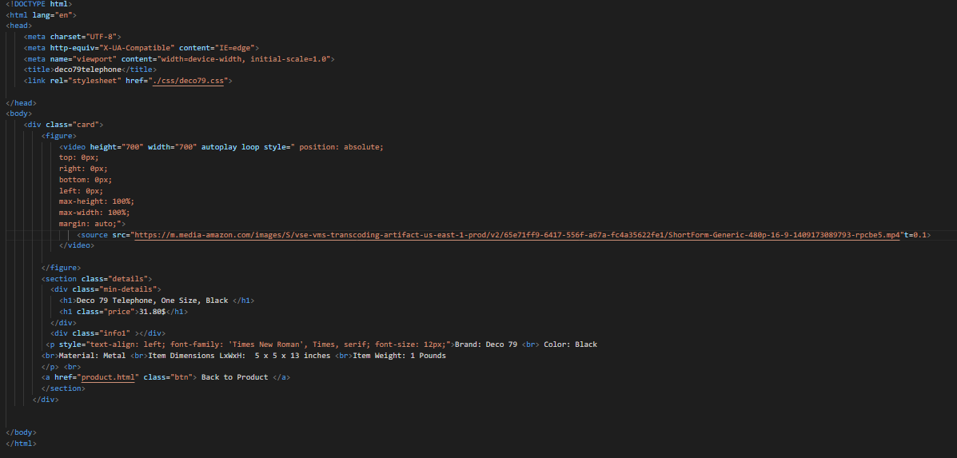

Figure 40: Product detail code

|  |  |
| --- | --- |
| Screenshot 2022-07-22 213600 | Screenshot 2022-07-22 213616 |

Figure 41: Product Detail

**Total Product Detail**

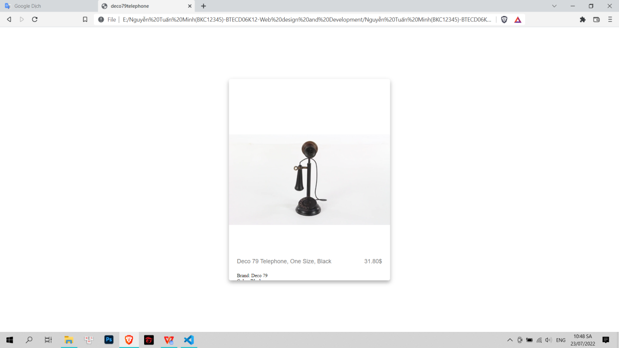

Figure 42: Product Detail Page

* **Contact**

The contact page helps customers understand the contact information of BKC Antiques, and also helps customers send reviews and feedback on quality, service as well as product suggestions.

**Contact Information**

Contact information helps customers know BKC's contact information

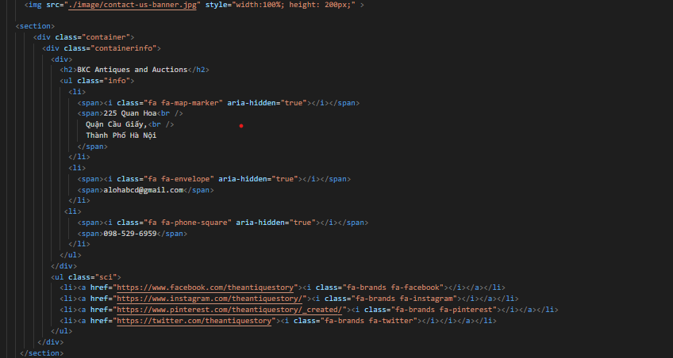

Figure 43: Contact information code



Figure 44: Contact information

**Contact Message**

Contact messages help customers send their feedback and reviews to BKC

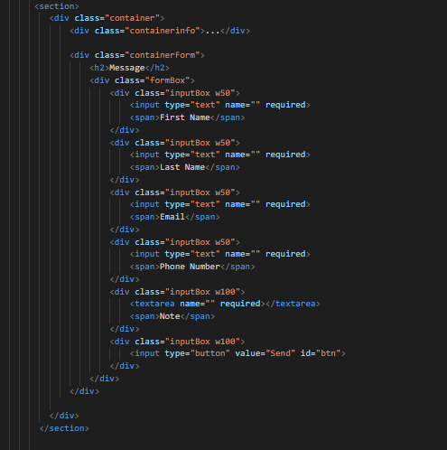

Figure 45: Contact Message code

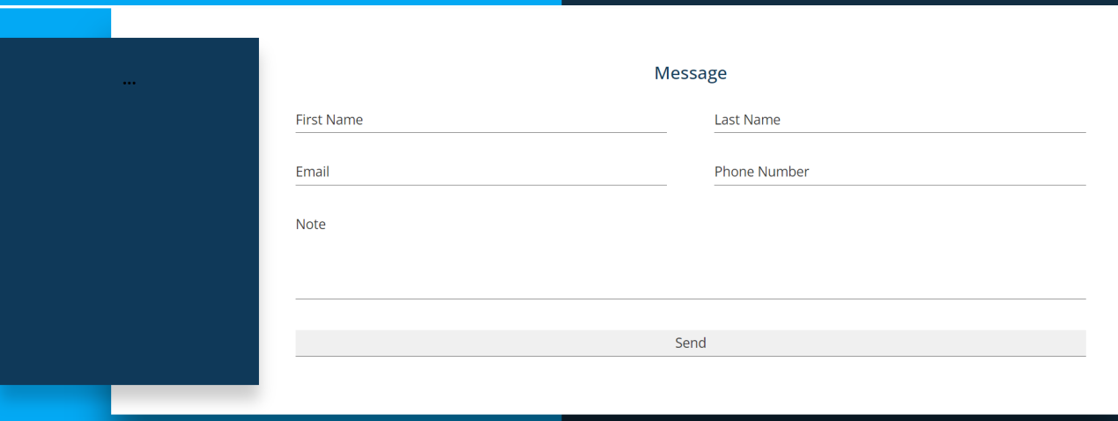

Figure 46: Contact Message

**Total Contact Page**

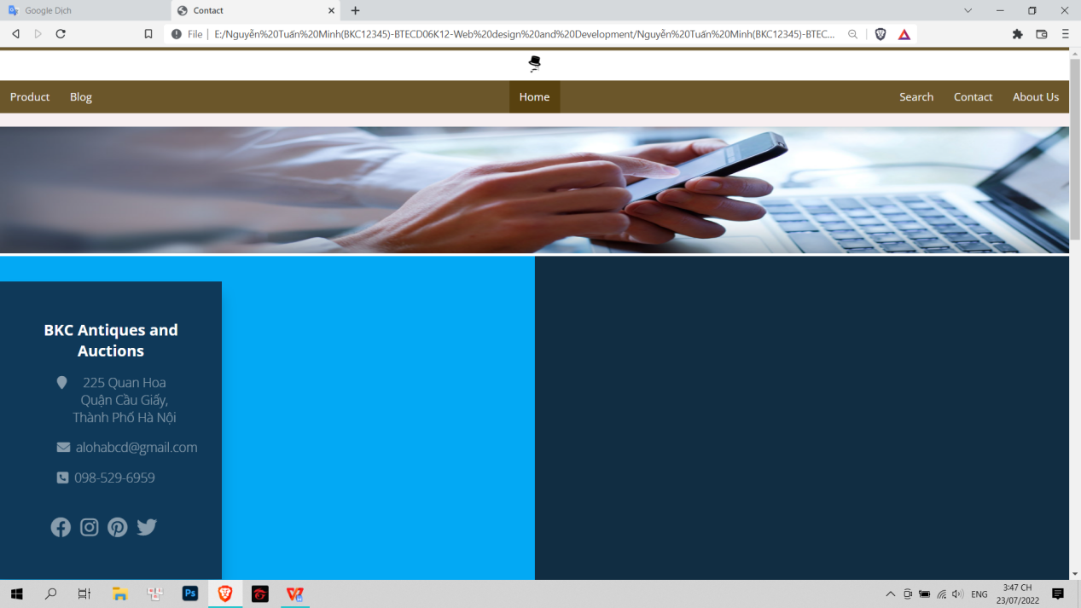

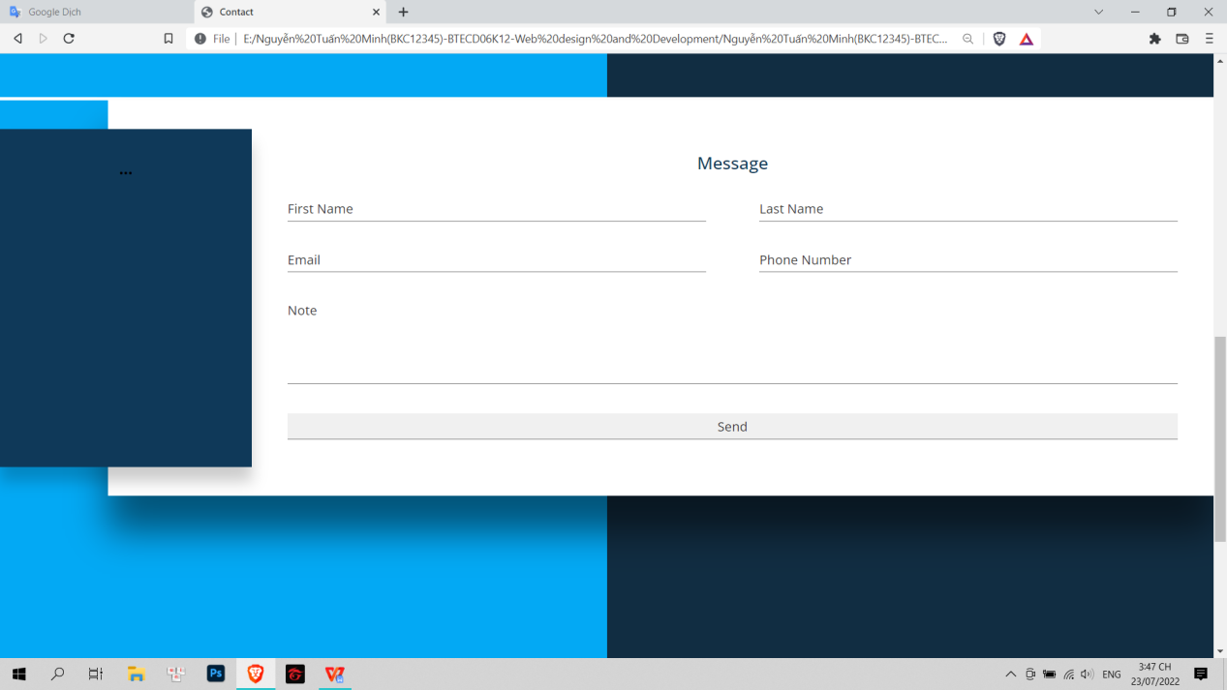

Figure 47: Contact Page

* **About Us**

The About Us page will provide customers with an overview of BKC's ideals, as well as the story or working style of BKC.

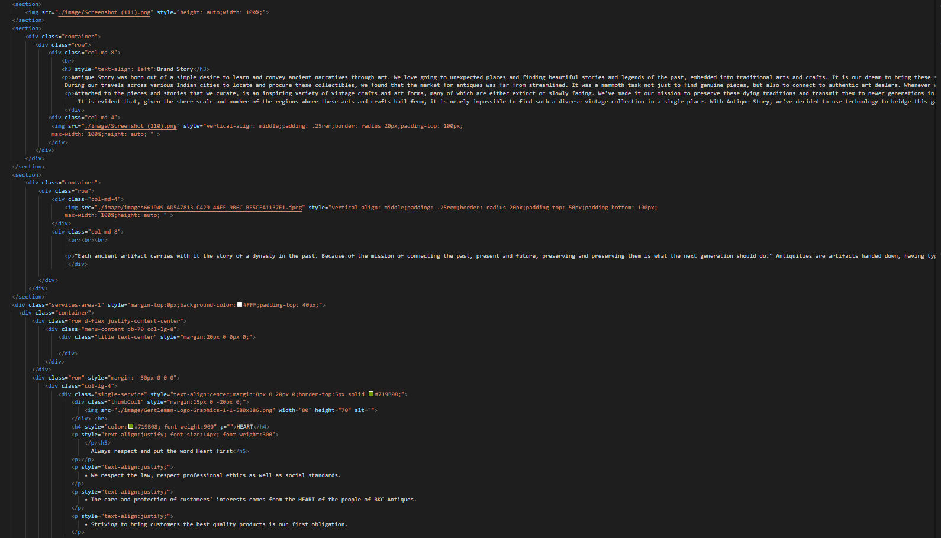

Figure 48: About Us Code

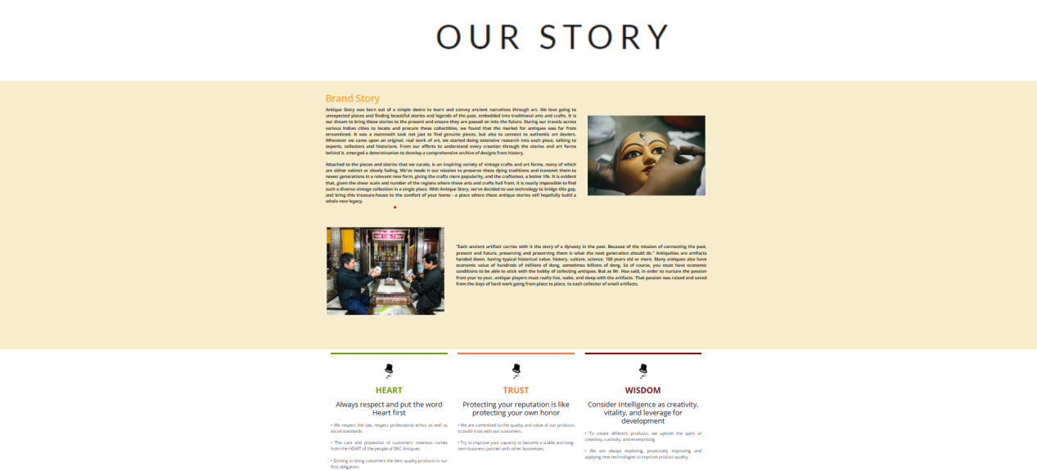

Figure 49: About Us Page

* **Blog**

Blog page gives users more information about newly unearthed items or famous places and monuments

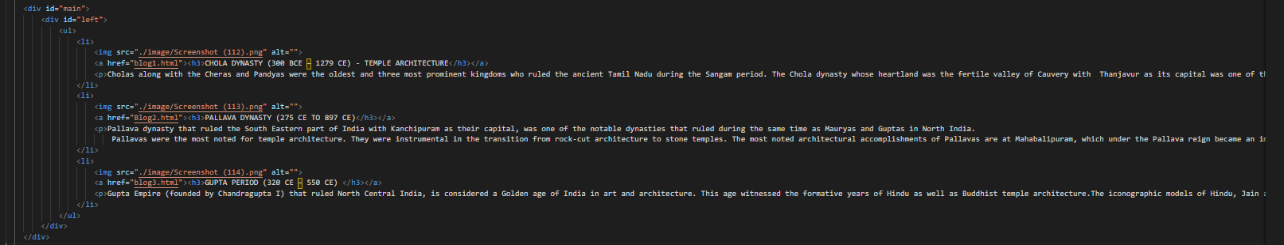

Figure 50: Blog code

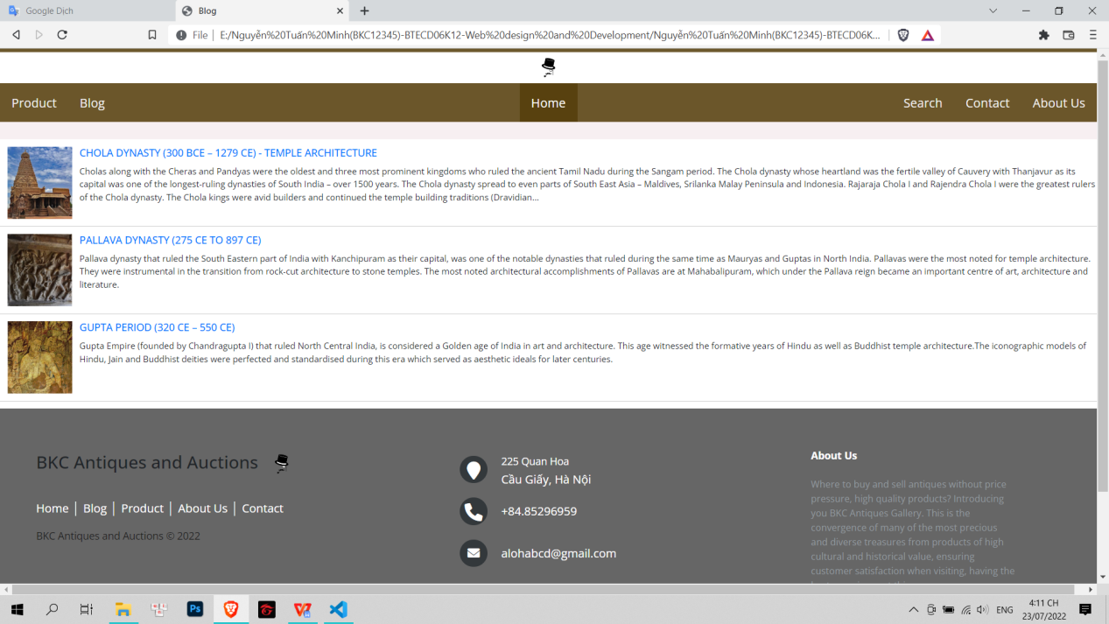

Figure 51: Blog Page

**Detail Blog**

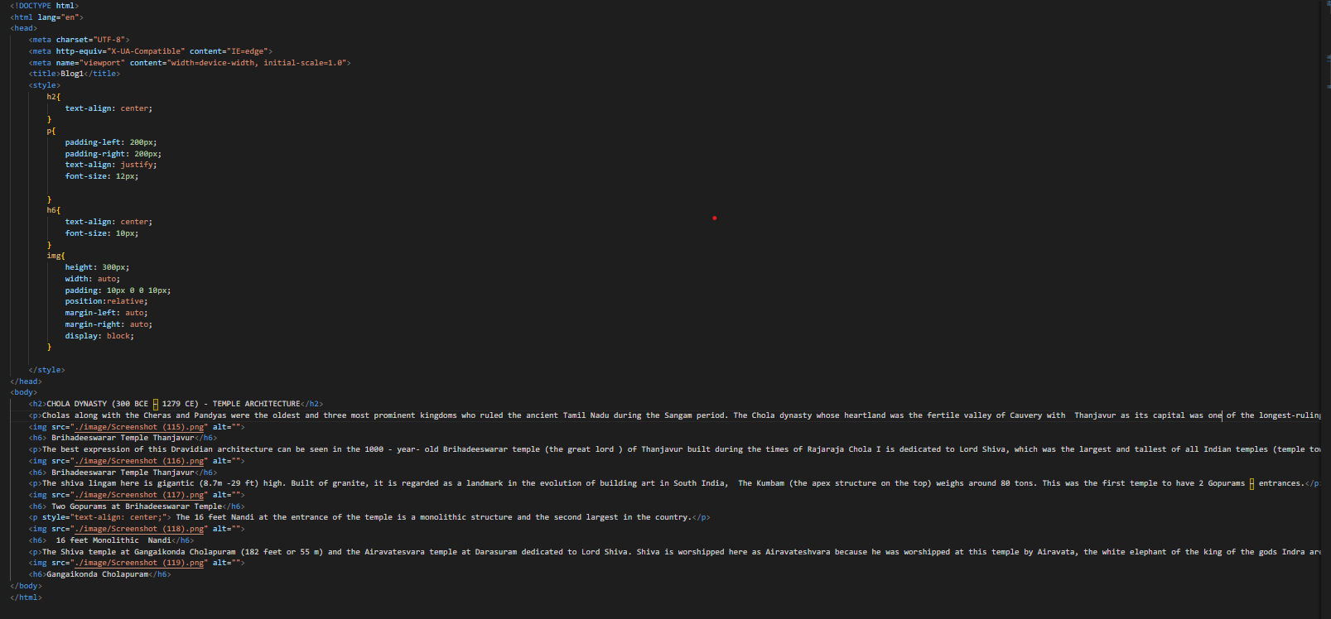

Figure 52: Detail Blog Code

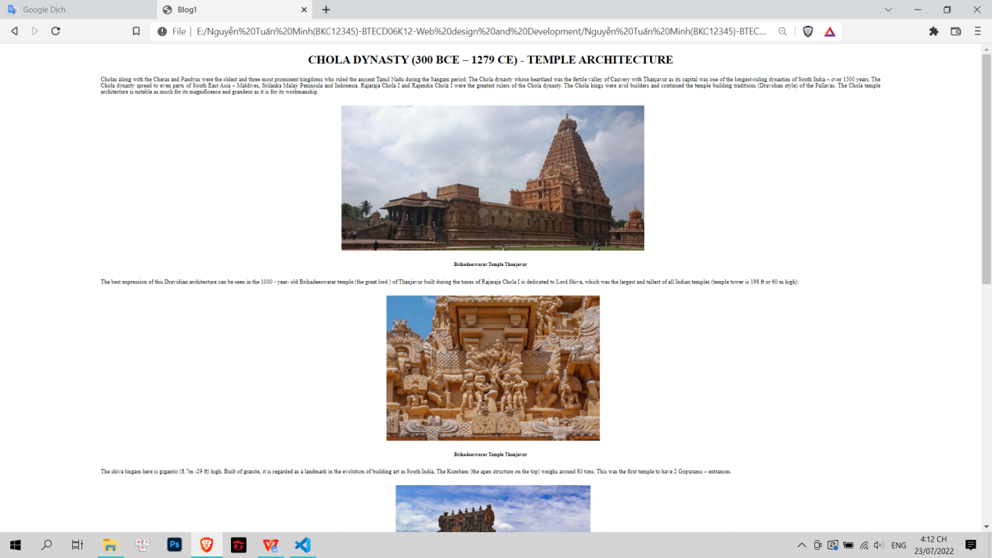

Figure 53: Detail Blog Page

* **Search**

The search page allows us to search for product categories faster, thereby finding products easier

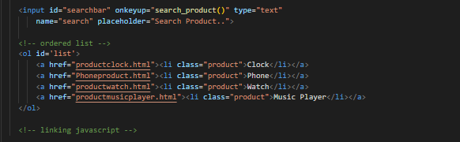

Figure 54: Search Code

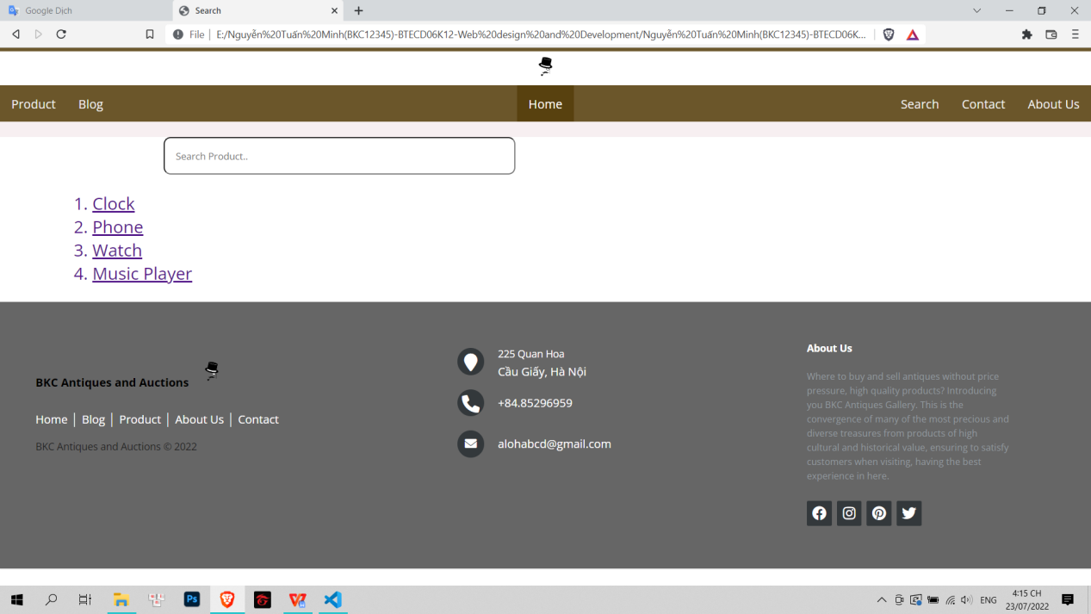

Figure 55: Search Page

* **Cart**

The cart page will show us the products we have added to the cart and make a purchase if we like it

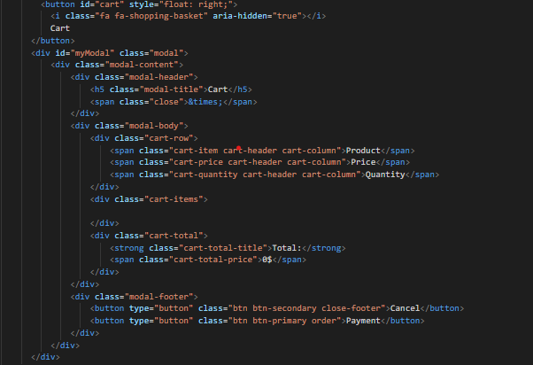

Figure 56: Cart Code



Figure 57: Cart Button

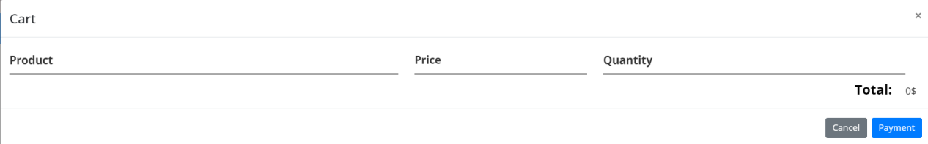

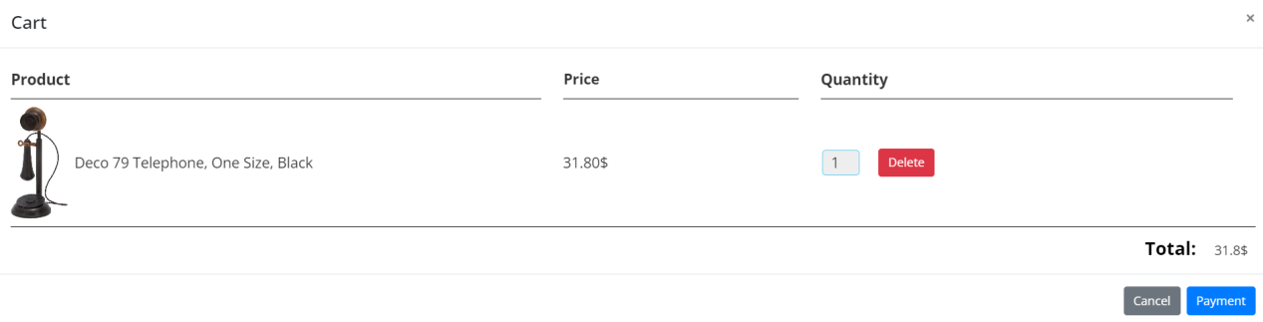

Figure 58: Cart Page

1. **Test**

* **Definition**

Software testing is a method of determining whether the actual software product meets the expected requirements and ensuring that the software product is free of defects. It entails running software/system components through their paces using manual or automated tools to evaluate one or more properties of interest.

* **Purpose**

**Helps in saving money**

The testing of software has a wide array of benefits. The cost-effectiveness of the project happens to be one of the top reasons why companies go for [software testing Services](https://www.indiumsoftware.com/software-testing-services/).

The testing of software comprises of a bunch of projects. In case you find any bug in the early phases, fixing them costs a reduced amount of money.

**Security**

It is another crucial point why software testing should not be taken into consideration.

It is considered to be the most vulnerable and sensitive part. There are a bunch of situations in which the information and details of the users are stolen and they are used for the benefits.

It is considered to be the reason why people look for the well tested and reliable products.

As a specific product undergoes testing, the user can be ensured that they are going to receive a reliable product. The personal details of the user can be safe. Users can receive products that are free from vulnerability with the aid of software testing.

**Enhancing the development process**

With the aid of Quality Assurance, you can find a wide array of scenarios and errors, for the reproduction of the error.

It is really simple and the developers need to fix the same in no time. In addition to this, software testers should be working with the development team parallelly, which is useful in the acceleration of the development procedure.

**Easy while adding new features**

The more interconnected and older the code, the more difficult it is to change. Tests counteract this calcification tendency by allowing developers to confidently add new features. As a new developer, changing older parts of your codebase can be terrifying, but with tests, you’ll at least know if you’ve broken anything important. This helps in making your software stand ahead in the market, and beat the competition.

**Test**

|  |  |  |  |  |
| --- | --- | --- | --- | --- |
| Case | Test Case Description | Step | Excepted result | Result |
| 1 | Test search bar | Step 1: Click to search page  Step 2: Click on seach bar  Step 3: Enter keyword  Step 4: Select the category that matches the keywords you need to search for | Find what customers need through keywords | Pass |
| 2 | Test aniamtion | Step 1: Hover over something (example: howver the picture in product detail page) | Animation do not break down and | Pass |
| 3 | Check link | Step 1: click on any link like category name, product, ... | Will go to the page of the link that the customer clicked on | Pass |
| 4 | Check the cart | Step 1: Click to product page and add any product to cart  Step 2: Click to cart button to see your detail cart |  |  |
| 5 | Update quantity product in cart | Step 1: Go in cart page (click to cart button )  Step 2: Click on the quantity of the product you want to add or subtract  Step 3: Enter the quantity you want | Product quantity can be changed | Pass |
| 6 | Delete product in cart | Step 1: Go to the cart page (cart button)  Step 2: Select the product you want to delete  Step 3: Click delete | Remove unnecessary products | Pass |
| 7 | Check form in contact page | Step 1: Go to contact page  Step 2: Enter information, feedback, suggestions  Step 3: Click send | Send success | Pass |

Table 5: Test Case

REFERENCE

Domain name system (DNS), 25/07/2022

<https://www.techtarget.com/searchnetworking/definition/domain-name-system>

What is DNS? | How DNS works, 25/07/2022

<https://www.cloudflare.com/learning/dns/what-is-dns/>

DNS: Types of DNS Records, DNS Servers and DNS Query Types, 25/07/2022

<https://ns1.com/resources/dns-types-records-servers-and-queries>

What is a Domain Name and What Does it Do?, 25/07/2022

<https://www.domaintools.com/support/what-is-a-domain-name-and-what-does-it-do#:~:text=Domain%20names%20are%20organized%20via,%2Dlevel%20domains%20(ccTLDs).>

[Quản lý tên miền là gì? Phân biệt nhà đăng ký và quản lý tên miền](https://tenten.vn/tin-tuc/quan-ly-ten-mien-la-gi/), 25/07/2022

<https://tenten.vn/tin-tuc/quan-ly-ten-mien-la-gi/>

Giao thức HTTP và HTTPS là gì? Tại sao nên sử dụng HTTPS?, 25/007/2022

<https://cystack.net/vi/blog/http-va-https-la-gi>

What is an operating system?, 25/07/2022

<https://edu.gcfglobal.org/en/computerbasics/understanding-operating-systems/1/>

Frontend vs Backend, 25/07/2022

<https://www.geeksforgeeks.org/frontend-vs-backend/>

Key Differences Between Client-side, Server-side and Pre-rendering, 25/07/2022

<https://gbksoft.com/blog/client-side-vs-server-side-vs-pre-rendering/>

Top 3 Front-end Technologies for Web Development in 2022, 25/07/2022

<https://www.ateamsoftsolutions.com/top-3-front-end-technologies-for-web-development-in-2022/>

What are the pros and cons of JSP?, 25/07/2022

<https://www.quora.com/What-are-the-pros-and-cons-of-JSP>

7 Reasons Why Software Testing is Important, 25/07/2022

<https://www.indiumsoftware.com/blog/why-software-testing/>